PISA Science Literacy Items

The Science Literacy Items document contains, in a ready-to-use format, 10 science assessment units and 31 items associated with these units. These released items from the PISA 2000 and PISA 2006 assessments are distinct from the secure items which are kept confidential so that they may be used in subsequent cycles to monitor trends. This set of PISA Science Literacy Items is designed to be used in tandem with PISA Science Literacy Items and Scoring Guides, which contains both the items and the PISA scoring guides adapted for classroom use.

tABLE OF cONTENTS
UNIT NAME PAGE
semmelweis’ diary 3
ozone 8
greenhouse 12
Genetically Modified CROPS 15

THE GRAND CANYON 17
Acid Rain 19
PHYSICAL EXERCISE 21
SUNSCREENS 23
mary montagu 26
Clothes 28

semmelweis’ diary

SEMMELWEIS’ DIARY TEXT 1

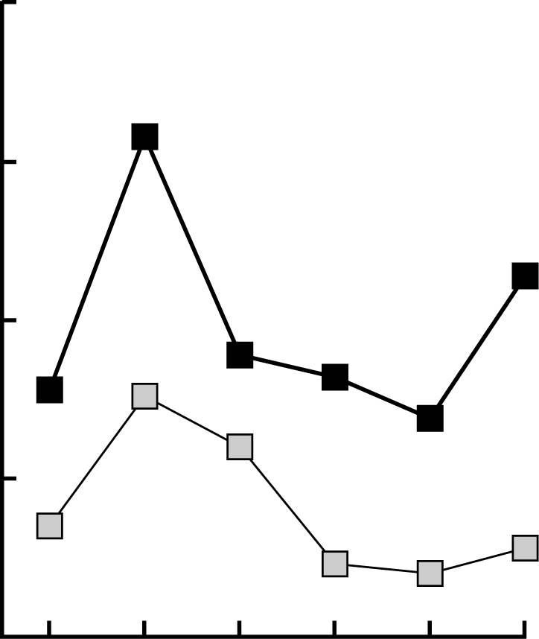
‘July 1846. Next week I will take up a position as “Herr Doktor” at the First Ward of the maternity clinic of the Vienna General Hospital. I was frightened when I heard about the percentage of patients who die in this clinic. This month not less than 36 of the 208 mothers died there, all from puerperal fever. Giving birth to a child is as dangerous as first-degree pneumonia.’
Diagram
1841 1842 1843 1844 1845 1846 Year
15
10
5
Number of Deaths
First Ward
Second Ward
Number of Deaths per 100 deliveries from puerperal fever
These lines from the diary of Ignaz Semmelweis (1818-1865) illustrate the devastating effects of puerperal fever, a contagious disease that killed many women after childbirth. Semmelweis collected data about the number of deaths from puerperal fever in both the First and the Second Wards (see diagram).

Physicians, among them Semmelweis, were completely in the dark about the cause of puerperal fever. Semmelweis’ diary again:
‘December 1846. Why do so many women die from this fever after giving birth without any problems? For centuries science has told us that it is an invisible epidemic that kills mothers. Causes may be changes in the air or some extraterrestrial influence or a movement of the earth itself, an earthquake.’
Nowadays not many people would consider extraterrestrial influence or an earthquake as possible causes of fever. We now know it has to do with hygienic conditions. But in the time Semmelweis lived, many people, even scientists, did! Semmelweis knew that it was unlikely that fever could be caused by extraterrestrial influence or an earthquake. He pointed at the data he collected (see diagram) and used this to try to persuade his colleagues.

Question 1: SEMMELWEIS’ DIARY S195Q02- 01 02 03 04 11 12 13 21 99

Suppose you were Semmelweis. Give a reason (based on the data Semmelweis collected) why puerperal fever is unlikely to be caused by earthquakes.

SEMMELWEIS’ DIARY TEXT 2

Part of the research in the hospital was dissection. The body of a deceased person was cut open to find a cause of death. Semmelweis recorded that the students working on the First ward usually took part in dissections on women who died the previous day, before they examined women who had just given birth. They did not pay much attention to cleaning themselves after the dissections. Some were even proud of the fact that you could tell by their smell that they had been working in the mortuary, as this showed how industrious they were!
One of Semmelweis’ friends died after having cut himself during such a dissection. Dissection of his body showed he had the same symptoms as mothers who died from puerperal fever. This gave Semmelweis a new idea.

Question 2: Semmelweis’ diary S195Q04

Semmelweis’ new idea had to do with the high percentage of women dying in the maternity wards and the students’ behavior.
What was this idea?
- Having students clean themselves after dissections should lead to a decrease of puerperal fever.
- Students should not take part in dissections because they may cut themselves.
- Students smell because they do not clean themselves after a dissection.
- Students want to show that they are industrious, which makes them careless when they examine the women.

Question 3: SEMMELWEIS’ DIARY S195Q05-01 02 11 12 13 14 15 99

Semmelweis succeeded in his attempts to reduce the number of deaths due to puerperal fever. But puerperal fever even today remains a disease that is difficult to eliminate.
Fevers that are difficult to cure are still a problem in hospitals. Many routine measures serve to control this problem. Among those measures are washing sheets at high temperatures.
Explain why high temperature (while washing sheets) helps to reduce the risk that patients will contract a fever.

Question 4: SEMMELWEIS’ DIARY S195Q06

Many diseases may be cured by using antibiotics. However, the success of some antibiotics against puerperal fever has diminished in recent years.
What is the reason for this?
- Once produced, antibiotics gradually lose their activity.
- Bacteria become resistant to antibiotics.
- These antibiotics only help against puerperal fever, but not against other diseases.
- The need for these antibiotics has been reduced because public health conditions have improved considerably in recent years.

ozone
Ozone text
Read the following section of an article about the ozone layer.
The atmosphere is an ocean of air and a precious natural resource for sustaining life on the Earth. Unfortunately, human activities based on national/personal interests are causing harm to this common resource, notably by depleting the fragile ozone layer, which acts as a protective shield for life on the Earth.
Ozone molecules consist of three oxygen atoms, as opposed to oxygen molecules which consist of two oxygen atoms. Ozone molecules are exceedingly rare: fewer than ten in every million molecules of air. However, for nearly a billion years, their presence in the atmosphere has played a vital role in safeguarding life on Earth. Depending on where it is located, ozone can either protect or harm life on Earth. The ozone in the troposphere (up to 10 kilometres above the Earth’s surface) is “bad” ozone which can damage lung tissues and plants. But about 90 percent of ozone found in the stratosphere (between 10 and 40 kilometres above the Earth’s surface) is “good” ozone which plays a beneficial role by absorbing dangerous ultraviolet (UV-B) radiation from the Sun.
Without this beneficial ozone layer, humans would be more susceptible to certain diseases due to the increased incidence of ultra-violet rays from the Sun. In the last decades the amount of ozone has decreased. In 1974 it was hypothesised that chlorofluorocarbons (CFCs) could be a cause for this. Until 1987, scientific assessment of the cause-effect relationship was not convincing enough to implicate CFCs. However, in September 1987, diplomats from around the world met in Montreal (Canada) and agreed to set sharp limits to the use of CFCs.

Source: Connect, UNESCO International Science, Technology & Environmental Education Newsletter, section from an article entitled “The Chemistry of Atmospheric policy”, Vol., XXII No. 2, 19978 (spelling adapted).

Question 1: OZONE S253Q01- 01 11 12 13 21 22 23 31 99

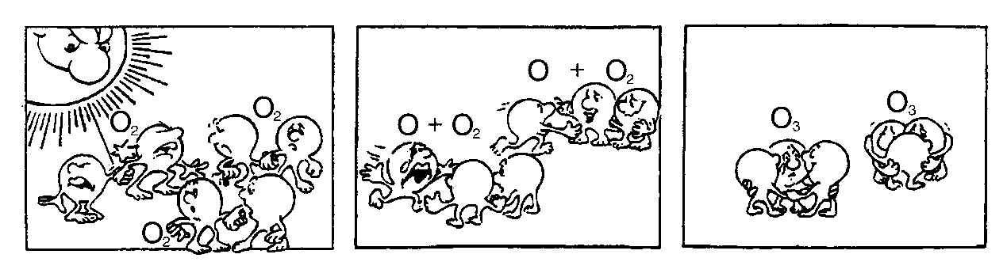
In the text above nothing is mentioned about the way ozone is formed in the atmosphere. In fact each day some ozone is formed and some other ozone disappears. The way ozone is formed is illustrated in the following comic strip.
Suppose you have an uncle who tries to understand the meaning of this strip. However, he did not get any science education at school and he doesn’t understand what the author of the strip is explaining. He knows that there are no little fellows in the atmosphere but he wonders what those little fellows in the strip stand for, what those strange notations O₂ and O₃ mean and which processes the strip represents. He asks you to explain the strip. Assume that your uncle knows:
- that O is the symbol for oxygen;
- what atoms and molecules are.

Write an explanation of the comic strip for your uncle.
In your explanation, use the words atoms and molecules in the way they are used in lines 5 and 6.

Question 2: Ozone S253Q02

Ozone is also formed during thunderstorms. It causes the typical smell after such a storm. In lines 9–13 the author of the text distinguishes between “bad ozone” and “good ozone”.
In terms of the article, is the ozone that is formed during thunderstorms “bad ozone” or “good ozone”?
Choose the answer and the explanation that is supported by the text.
 | Bad ozone or good ozone? | Explanation
- A | Bad | It is formed during bad weather.
- B | Bad | It is formed in the troposphere.
- C | Good | It is formed in the stratosphere.
 | Good | It smells good.

Question 3: OZONE S253Q05- 019

Lines 14 and 15 state: “Without this beneficial ozone layer, humans would be more susceptible to certain diseases due to the increased incidence of ultra-violet rays from the Sun.”
Name one of these specific diseases.

Question 4: OZONE S270Q03

At the end of the text, an international meeting in Montreal is mentioned. At that meeting lots of questions in relation to the possible depletion of the ozone layer were discussed. Two of those questions are shown in the table below.
Can the questions listed below be answered by scientific research?
Circle either Yes or No for each.
Question | Answerable by scientific research?
Should the scientific uncertainties about the influence of CFCs on the ozone layer be a reason for governments to take no action? | Yes / No
What would the concentration of CFCs be in the atmosphere in the year 2002 if the release of CFCs into the atmosphere takes place at the same rate as it does now? | Yes / No

greenhouse
Read the texts and answer the questions that follow.
the greenhouse effect: fact or fiction?
Living things need energy to survive. The energy that sustains life on the Earth comes from the Sun, which radiates energy into space because it is so hot. A tiny proportion of this energy reaches the Earth.
The Earth’s atmosphere acts like a protective blanket over the surface of our planet, preventing the variations in temperature that would exist in an airless world.
Most of the radiated energy coming from the Sun passes through the Earth’s atmosphere. The Earth absorbs some of this energy, and some is reflected back from the Earth’s surface. Part of this reflected energy is absorbed by the atmosphere.
As a result of this the average temperature above the Earth’s surface is higher than it would be if there was no atmosphere. The Earth’s atmosphere has the same effect as a greenhouse, hence the term greenhouse effect.
The greenhouse effect is said to have become more pronounced during the twentieth century.
It is a fact that the average temperature of the Earth’s atmosphere has increased. In newspapers and periodicals the increased carbon dioxide emission is often stated as the main source of the temperature rise in the twentieth century.

A student named André becomes interested in the possible relationship between the average temperature of the Earth’s atmosphere and the carbon dioxide emission on the Earth.
In a library he comes across the following two graphs.
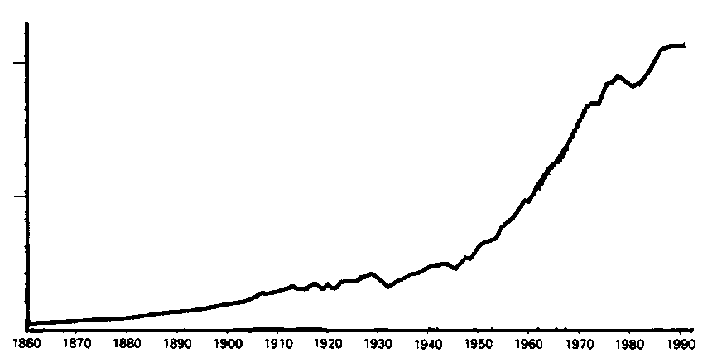
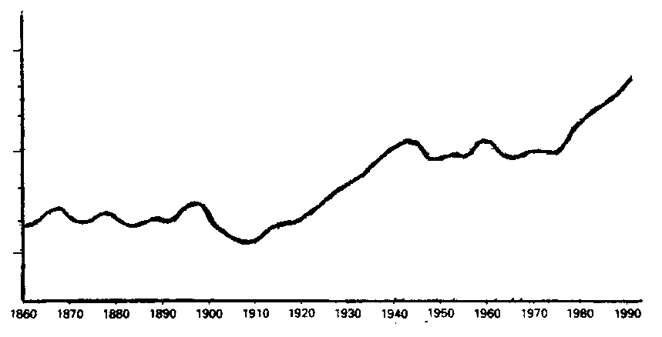
André concludes from these two graphs that it is certain that the increase in the average temperature of the Earth’s atmosphere is due to the increase in the carbon dioxide emission.
⎯→
Years
Carbon dioxide emission ↑
(thousand millions of tons per year)
20
10
1860
1870
1880
1890
1900
1910
1920
1930
1940
1950
1960
1970
1980
1990
⎯→
Years
1860
1870
1880
1890
1900
1910
1920
1930
1940
1950
1960
1970
1980
1990
15.4
15.0
14.6
Average temperature
of the Earth's ↑
atmosphere (°C)

Question 1: GREENHOUSE S114Q03- 01 02 11 12 99

What is it about the graphs that supports André’s conclusion?

Question 2: GREENHOUSE S114Q04- 01 02 03 11 12 13 14 15 21 99

Another student, Jeanne, disagrees with André’s conclusion. She compares the two graphs and says that some parts of the graphs do not support his conclusion.
Give an example of a part of the graphs that does not support André’s conclusion. Explain your answer.

Question 3: GREENHOUSE S114Q05- 01 02 03 11 12 99

André persists in his conclusion that the average temperature rise of the Earth’s atmosphere is caused by the increase in the carbon dioxide emission. But Jeanne thinks that his conclusion is premature. She says: “Before accepting this conclusion you must be sure that other factors that could influence the greenhouse effect are constant”.
Name one of the factors that Jeanne means.

Genetically Modified CROPS
GM Corn Should Be Banned
Wildlife conservation groups are demanding that a new genetically modified (GM) corn be banned.
This GM corn is designed to be unaffected by a powerful new herbicide that kills conventional corn plants. This new herbicide will kill most of the weeds that grow in cornfields.
The conservationists say that because these weeds are feed for small animals, especially insects, the use of the new herbicide with the GM corn will be bad for the environment. Supporters of the use of the GM corn say that a scientific study has shown that this will not happen.

Here are details of the scientific study mentioned in the above article:
- Corn was planted in 200 fields across the country.
- Each field was divided into two. The genetically modified (GM) corn treated with the powerful new herbicide was grown in one half, and the conventional corn treated with a conventional herbicide was grown in the other half.
- The number of insects found in the GM corn, treated with the new herbicide, was about the same as the number of insects in the conventional corn, treated with the conventional herbicide.

Question 1: GENETICALLY MODIFIED CROPS S508Q02

What factors were deliberately varied in the scientific study mentioned in the article? Circle “Yes” or “No” for each of the following factors.
Was this factor deliberately varied in the study? | Yes or No?
The number of insects in the environment | Yes / No
The types of herbicide used | Yes / No

Question 2: GENETICALLY MODIFIED CROPS S508Q03

Corn was planted in 200 fields across the country. Why did the scientists use more than one site?
- So that many farmers could try the new GM corn.
- To see how much GM corn they could grow.
- To cover as much land as possible with the GM crop.
- To include various growth conditions for corn.

The Grand Canyon
The Grand Canyon is located in a desert in the USA. It is a very large and deep canyon containing many layers of rock. Sometime in the past, movements in the Earth’s crust lifted these layers up. The Grand Canyon is now 1.6 km deep in parts. The Colorado River runs through the bottom of the canyon.
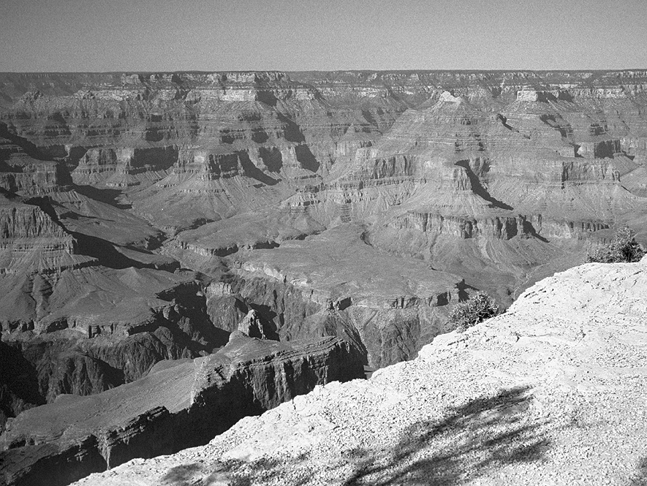
See the picture below of the Grand Canyon taken from its south rim. Several different layers of rock can be seen in the walls of the canyon.
Limestone A
Shale A
Limestone B
Shale B
Schists and granite

Question 1: THE GRAND CANYON S426Q07

About five million people visit the Grand Canyon national park every year. There is concern about the damage that is being caused to the park by so many visitors.
Can the following questions be answered by scientific investigation? Circle “Yes” or “No” for each question.
Can this question be answered by scientific investigation? | Yes or No?
How much erosion is caused by use of the walking tracks? | Yes / No
Is the park area as beautiful as it was 100 years ago? | Yes / No

Question 2: THE GRAND CANYON S426Q03

The temperature in the Grand Canyon ranges from below 0 ºC to over 40 ºC. Although it is a desert area, cracks in the rocks sometimes contain water. How do these temperature changes and the water in rock cracks help to speed up the breakdown of rocks?
- Freezing water dissolves warm rocks.
- Water cements rocks together.
- Ice smoothes the surface of rocks.
- Freezing water expands in the rock cracks.

Question 3: THE GRAND CANYON S426Q05

There are many fossils of marine animals, such as clams, fish and corals, in the Limestone A layer of the Grand Canyon. What happened millions of years ago that explains why such fossils are found there?
- In ancient times, people brought seafood to the area from the ocean.
- Oceans were once much rougher and sea life washed inland on giant waves.
- An ocean covered this area at that time and then receded later.
- Some sea animals once lived on land before migrating to the sea.

Acid Rain
Below is a photo of statues called Caryatids that were built on the Acropolis in Athens more than 2500 years ago. The statues are made of a type of rock called marble. Marble is composed of calcium carbonate.
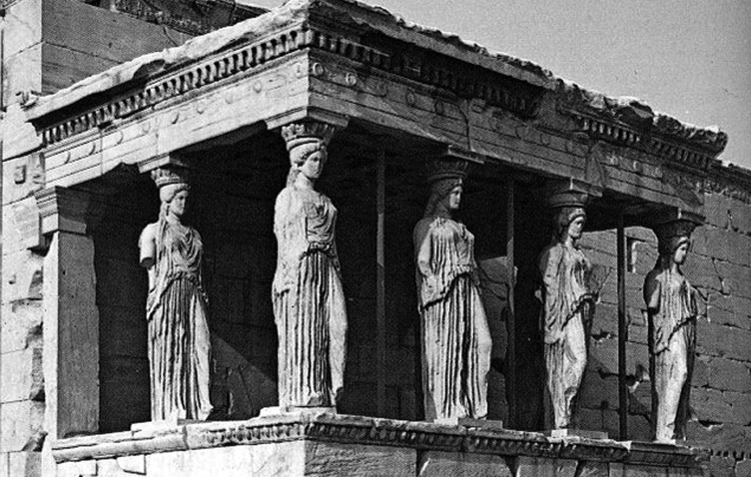
In 1980, the original statues were transferred inside the museum of the Acropolis and were replaced by replicas. The original statues were being eaten away by acid rain.

Question 1: ACID RAIN S485Q02 – 0129

Normal rain is slightly acidic because it has absorbed some carbon dioxide from the air. Acid rain is more acidic than normal rain because it has absorbed gases like sulphur oxides and nitrogen oxides as well.
Where do these sulphur oxides and nitrogen oxides in the air come from?

The effect of acid rain on marble can be modelled by placing chips of marble in vinegar overnight. Vinegar and acid rain have about the same acidity level. When a marble chip is placed in vinegar, bubbles of gas form. The mass of the dry marble chip can be found before and after the experiment.

Question 2: ACID RAIN S485Q03

A marble chip has a mass of 2.0 grams before being immersed in vinegar overnight. The chip is removed and dried the next day. What will the mass of the dried marble chip be?
- Less than 2.0 grams
- Exactly 2.0 grams
- Between 2.0 and 2.4 grams
- More than 2.4 grams

Question 3: ACID RAIN S485Q05 – 0129

Students who did this experiment also placed marble chips in pure (distilled) water overnight.
Explain why the students include this step in their experiment.

PHYSICAL EXERCISE
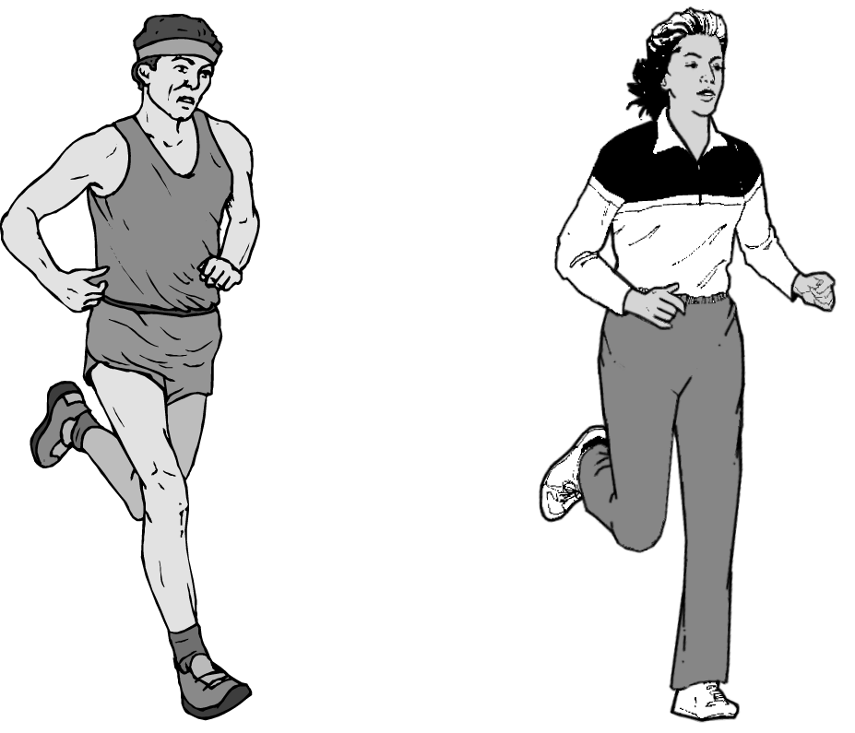
Regular but moderate physical exercise is good for our health.

Question 1: PHYSICAL EXERCISE S493Q01

What are the advantages of regular physical exercise? Circle “Yes” or “No” for each statement.
Is this an advantage of regular physical exercise? | Yes or No?
Physical exercise helps prevent heart and circulation illnesses. | Yes / No
Physical exercise leads to a healthy diet. | Yes / No
Physical exercise helps to avoid becoming overweight. | Yes / No

Question 2: PHYSICAL EXERCISE S493Q03

What happens when muscles are exercised? Circle “Yes” or “No” for each statement.
Does this happen when muscles are exercised? | Yes or No?
Muscles get an increased flow of blood. | Yes / No
Fats are formed in the muscles. | Yes / No

Question 3: PHYSICAL EXERCISE S493Q05 – 01 11 12 99

Why do you have to breathe more heavily when you’re doing physical exercise than when your body is resting?

SUNSCREENS
Mimi and Dean wondered which sunscreen product provides the best protection for their skin. Sunscreen products have a Sun Protection Factor (SPF) that shows how well each product absorbs the ultraviolet radiation component of sunlight. A high SPF sunscreen protects skin for longer than a low SPF sunscreen.
Mimi thought of a way to compare some different sunscreen products. She and Dean collected the following:
- two sheets of clear plastic that do not absorb sunlight;
- one sheet of light-sensitive paper;
- mineral oil (M) and a cream containing zinc oxide (ZnO); and
- four different sunscreens that they called S1, S2, S3, and S4.
Mimi and Dean included mineral oil because it lets most of the sunlight through, and zinc oxide because it almost completely blocks sunlight.
Dean placed a drop of each substance inside a circle marked on one sheet of plastic, and then put the second plastic sheet over the top. He placed a large book on top of both sheets and pressed down.
M
S1
ZnO
S2
S3
S4
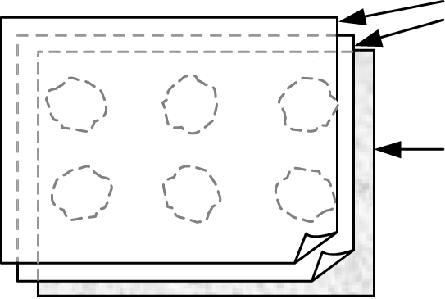
Mimi then put the plastic sheets on top of the sheet of light-sensitive paper. Light-sensitive paper changes from dark gray to white (or very light gray), depending on how long it is exposed to sunlight. Finally, Dean placed the sheets in a sunny place.
plastic sheets
light-sensitive paper

Question 1: SUNSCREENS S447Q02

Which one of these statements is a scientific description of the role of the mineral oil and the zinc oxide in comparing the effectiveness of the sunscreens?
- Mineral oil and zinc oxide are both factors being tested.
- Mineral oil is a factor being tested and zinc oxide is a reference substance.
- Mineral oil is a reference substance and zinc oxide is a factor being tested.
- Mineral oil and zinc oxide are both reference substances.

Question 2: SUNSCREENS S447Q03

Which one of these questions were Mimi and Dean trying to answer?
- How does the protection for each sunscreen compare with the others?
- How do sunscreens protect your skin from ultraviolet radiation?
- Is there any sunscreen that gives less protection than mineral oil?
- Is there any sunscreen that gives more protection than zinc oxide?

Question 3: SUNSCREENS S447Q04

Why was the second sheet of plastic pressed down?
- To stop the drops from drying out.
- To spread the drops out as far as possible.
- To keep the drops inside the marked circles.
- To make the drops the same thickness.

Question 4: SUNSCREENS S447Q05 – 0129

The light-sensitive paper is a dark gray and fades to a lighter gray when it is exposed to some sunlight, and to white when exposed to a lot of sunlight.
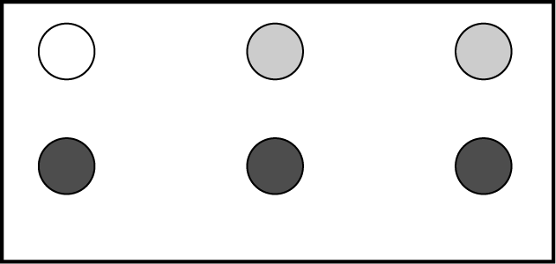
Which one of these diagrams shows a pattern that might occur? Explain why you chose it.
ZnO
S1
S2
S4
S3
M
A
ZnO
S1
S2
S4
S3
M
C
ZnO
S1
S2
S4
S3
M
B
ZnO
S1
S2
S4
S3
M
D
Answer:
Explanation:

mary montagu
Read the following newspaper article and answer the questions that follow.
the history of Vaccination
Mary Montagu was a beautiful woman. She survived an attack of smallpox in 1715 but she was left covered with scars. While living in Turkey in 1717, she observed a method called inoculation that was commonly used there. This treatment involved scratching a weak type of smallpox virus into the skin of healthy young people who then became sick, but in most cases only with a mild form of the disease.
Mary Montagu was so convinced of the safety of these inoculations that she allowed her son and daughter to be inoculated.
In 1796, Edward Jenner used inoculations of a related disease, cowpox, to produce antibodies against smallpox. Compared with the inoculation of smallpox, this treatment had less side effects and the treated person could not infect others. The treatment became known as vaccination.

Question 1: MARY MONTAGU S477Q02

What kinds of diseases can people be vaccinated against?
- Inherited diseases like haemophilia.
- Diseases that are caused by viruses, like polio.
- Diseases from the malfunctioning of the body, like diabetes.
- Any sort of disease that has no cure.

Question 2: MARY MONTAGU S477Q03

If animals or humans become sick with an infectious bacterial disease and then recover, the type of bacteria that caused the disease does not usually make them sick again.
What is the reason for this?
- The body has killed all bacteria that may cause the same kind of disease.
- The body has made antibodies that kill this type of bacteria before they multiply.
- The red blood cells kill all bacteria that may cause the same kind of disease.
- The red blood cells capture and get rid of this type of bacteria from the body.

Question 3: MARY MONTAGU S477Q04 – 019

Give one reason why it is recommended that young children and old people, in particular, should be vaccinated against influenza (flu).

Clothes
Read the text and answer the questions that follow.
clothes text
A team of British scientists is developing “intelligent” clothes that will give disabled children the power of “speech”. Children wearing waistcoats made of a unique electrotextile, linked to a speech synthesiser, will be able to make themselves understood simply by tapping on the touch-sensitive material.
The material is made up of normal cloth and an ingenious mesh of carbon-impregnated fibers that can conduct electricity. When pressure is applied to the fabric, the pattern of signals that passes through the conducting fibers is altered and a computer chip can work out where the cloth has been touched. It then can trigger whatever electronic device is attached to it, which could be no bigger than two boxes of matches.
“The smart bit is in how we weave the fabric and how we send signals through it – and we can weave it into existing fabric designs so you cannot see it’s in there,” says one of the scientists.
Without being damaged, the material can be washed, wrapped around objects or scrunched up. The scientist also claims it can be mass-produced cheaply.
Source: Steve Farrer, `Interactive fabric promises a material gift of the garb’, The Australian, 10 August 1998.

Question 1: CLOTHES S213Q01

Can these claims made in the article be tested through scientific investigation in the laboratory?
Circle either “Yes” or “No” for each.
The material can be | Can the claim be tested through scientific investigation in the laboratory?
washed without being damaged. | Yes / No
wrapped around objects without being damaged. | Yes / No
scrunched up without being damaged. | Yes / No
mass-produced cheaply. | Yes / No

Question 2: Clothes S213Q02

Which piece of laboratory equipment would be among the equipment you would need to check that the fabric is conducting electricity?
- Voltmeter
- Light box
- Micrometer
- Sound meter

