PISA Mathematics Literacy Items and Scoring Guides
The Mathematics Literacy Items and Scoring Guides document contains 27 mathematics assessment units and 43 items associated with these units. These released items from the PISA 2000 and PISA 2003 assessments are distinct from the secure items, which are kept confidential so that they may be used in subsequent cycles to monitor trends.

TABLE OF CONTENTS
UNIT NAME PAGE
APPLES 3
Continent Area 7
SPEED OF RACING CAR 10
Triangles 15
FARMS 16
CUBES 19
GROWING UP 21
Walking 25
ROBBERIES 29
CARPENTER 31
internet Relay chat 33
exchange rate 36
exports 39
Colored Candies 42
SCIENCE TESTS 43
bookshelves 44
LITTER 45
earthquake 47
CHOICES 48
TEST SCORES 49
Skateboard 51
staircase 55
NUMBER CUBES 56
SUPPORT FOR THE PRESIDENT 58
the best caR 59
step pattern 62
forecast of rainfall 63

APPLES

A farmer plants apple trees in a square pattern. In order to protect the trees against the wind he plants conifers all around the orchard.
Here you see a diagram of this situation where you can see the pattern of apple trees and conifers for any number (n) of rows of apple trees:
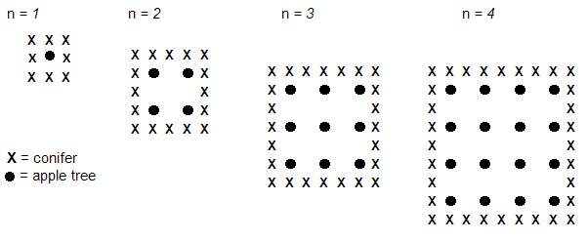
Question 1: APPLES M136Q01-01 02 11 12 21 99
Question intent: Change and relationships
Complete the table:
n | Number of apple trees | Number of conifers
1 | 1 | 8
2 | 4
3
4
5

SCORING:
Correct

Answers which show all 7 entries correct. Correct entries shown in italics.

n | Number of apple trees | Number of conifers
1 | 1 | 8
2 | 4 | 16
3 | 9 | 24
4 | 16 | 32
5 | 25 | 40

Incorrect
Two or more errors.
Other responses.
Percentage of students answering correctly in PISA 2000:

OECD average: 50%
U.S.: 53%

Question 2: APPLES M136Q02-00 11 12 13 14 15 99
Question intent: Change and relationships

There are two formulas you can use to calculate the number of apple trees and the number of conifers for the pattern described above:
Number of apple trees = 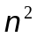
Number of conifers = 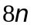
where n is the number of rows of apple trees.
There is a value of n for which the number of apple trees equals the number of conifers. Find the value of n and show your method of calculating this.

SCORING:
Correct
Responses with the correct answer, n=8.

Responses including both the answers n=8 AND n=0.

Incorrect

Other responses, including just the response n=0.

Percentage of students answering correctly in PISA 2000:

OECD average: 25%
U.S.: 24%

Question 3: APPLES M136Q03-01 02 11 12 21 99
Question intent: Change and relationships

Suppose the farmer wants to make a much larger orchard with many rows of trees. As the farmer makes the orchard bigger, which will increase more quickly: the number of apple trees or the number of conifers? Explain how you found your answer.

SCORING:
Fully Correct

Answers which are correct (apple trees) AND which give some algebraic explanations based on the formulas n² and 8n.

Partially Correct

Answers which are correct (apple trees) AND are based on specific examples or on extending the table.

Answers which are correct (apple trees) and show SOME evidence that the relationship between n² and 8n is understood, but not so clearly expressed as in Full Credit.

Incorrect

Answers which are correct (apple trees) but give an insufficient or wrong explanation, or no explanation.

Other responses.

Percentage of students answering correctly in PISA 2000:

OECD average: 13%
U.S.: 15%

Continent Area

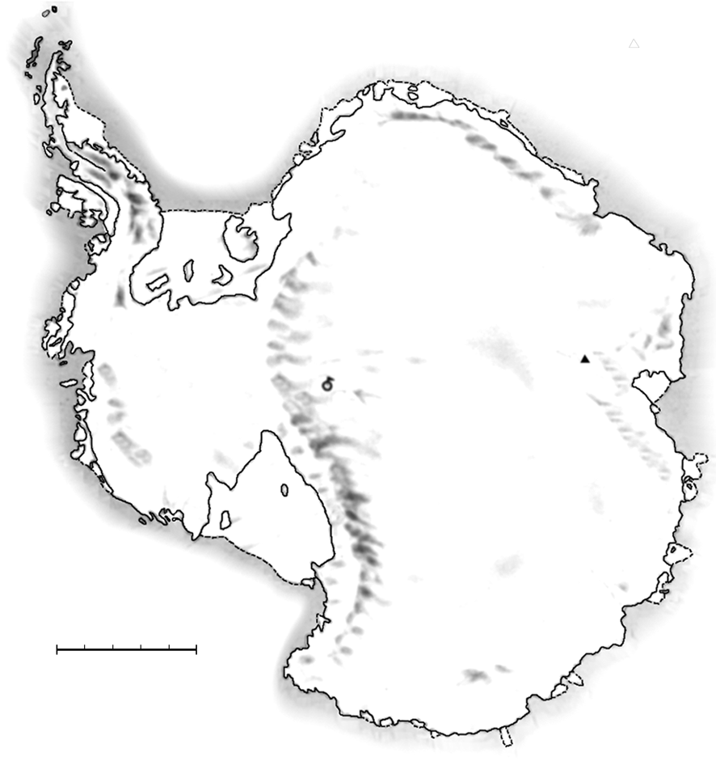
Below is a map of Antarctica.
ANTARCTICA
South Pole
Mt Menzies
Kilometers0 200 400 600 800 1000
Question 1: CONTINENT AREA M148Q02
Content: Space and shape

Estimate the area of Antarctica using the map scale.
Show your work and explain how you made your estimate. (You can draw over the map if it helps you with your estimation)

SCORING:

Fully Correct

These scores are for answers that use the correct method AND give the correct result. The digit indicates the different approaches.
- Answers which are estimated by drawing a square or rectangle- between 12,000,000 sq kms and 18,000,000 sq kms (units not required).
- Answers which are estimated by drawing a circle- between 12,000,000 sq kms and 18,000,000 sq kms.
- Answers which are estimated by adding areas of several geometric figures- between 12,000,000 sq kms and 18,000,000 sq kms.
- Answers which are estimated by other correct methods- between 12,000,000 sq kms and 18,000,000 sq kms.
- Answers which are correct (between 12,000,000 sq kms and 18,000,000 sq kms) but no working out is shown.
Partially Correct

These scores are for answers that use the correct method BUT give an incorrect or incomplete result. The digit indicates the different approaches, matching the digit of the Fully Correct scores.
- Answers which are estimated by drawing a square or rectangle- correct method but incorrect or incomplete answer.
- Answers which are estimated by drawing a circle- correct method but incorrect or incomplete answer.
- Answers which are estimated by adding areas of several regular geometric figures- correct method but incorrect or incomplete answer.
- Answers which are estimated by other correct methods- correct method but incorrect or incomplete answer.
Incorrect

Answers which calculate the perimeter instead of area.
Other responses.
Percentage of students answering correctly in PISA 2000:

OECD average: 20%
U.S.: 21%

SPEED OF RACING CAR
This graph shows how the speed of a racing car varies along a flat 3 kilometer track during its second lap.
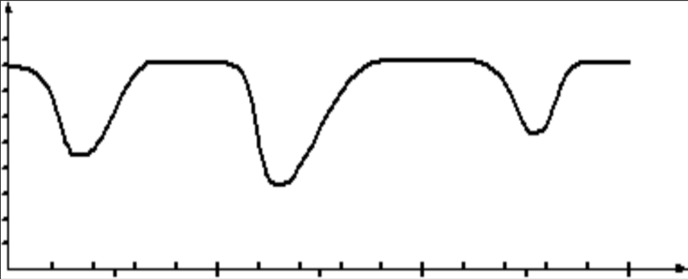
Speed
(km/h)
180
160
140
120
100
80
60
40
20
0
0
0.2
0.4
0.6
0.8
1.0
1.2
1.4
1.6
1.8
2.0
2.2
2.4
2.6
2.8
3.0
0.5
1.5
2.5
Starting line
Distance along the track (km)
Speed of a racing car along a 3 km track
(second lap)
Source: In memory of Claude Janvier, who died in June 1998. Modified task after these ideas in Janvier, C. (1978): The interpretation of complex graphs – studies and teaching experiments. Accompanying brochure to the Dissertation. University of Nottingham, Shell Centre for Mathematical Education, Item C-2.
The pictures of the tracks are taken from Fischer, R & Malle, G. (1985): Mensch und Mathematik. Bibliographisches Institut: Mannheim-Wien-Zurich, 234-238.

Question 1: SPEED OF RACING CAR M159Q01
Question intent: Change and relationships

What is the approximate distance from the starting line to the beginning of the longest straight section of the track?
- 0.5 km
- 1.5 km
- 2.3 km
- 2.6 km
SCORING:

Correct

Answer B. 1.5 km

Incorrect

Other responses.

Percentage of students answering correctly in PISA 2000:

OECD average: 67%
U.S.: 62%

Question 2: SPEED OF RACING CAR M159Q02
Question intent: Change and relationships

Where was the lowest speed recorded during the second lap?
- At the starting line.
- At about 0.8 km.
- At about 1.3 km.
- Halfway around the track.

SCORING:

Correct

Answer C. At about 1.3 km.

Incorrect

Other responses.

Percentage of students answering correctly in PISA 2000:

OECD average: 83%
U.S.: 83%

Question 3: SPEED OF RACING CAR M159Q03
Question intent: Change and relationships

What can you say about the speed of the car between the 2.6 km and 2.8 km marks?
- The speed of the car remains constant.
- The speed of the car is increasing.
- The speed of the car is decreasing.
- The speed of the car cannot be determined from the graph.

SCORING:

Correct

Answer B. The speed of the car is increasing.

Incorrect

Other responses.

Percentage of students answering correctly in PISA 2000:

OECD average: 83%
U.S.: 82%

Question 4: SPEED OF RACING CAR M159Q05
Question intent: Change and relationships

Here are pictures of five tracks:
Along which one of these tracks was the car driven to produce the speed graph shown earlier?
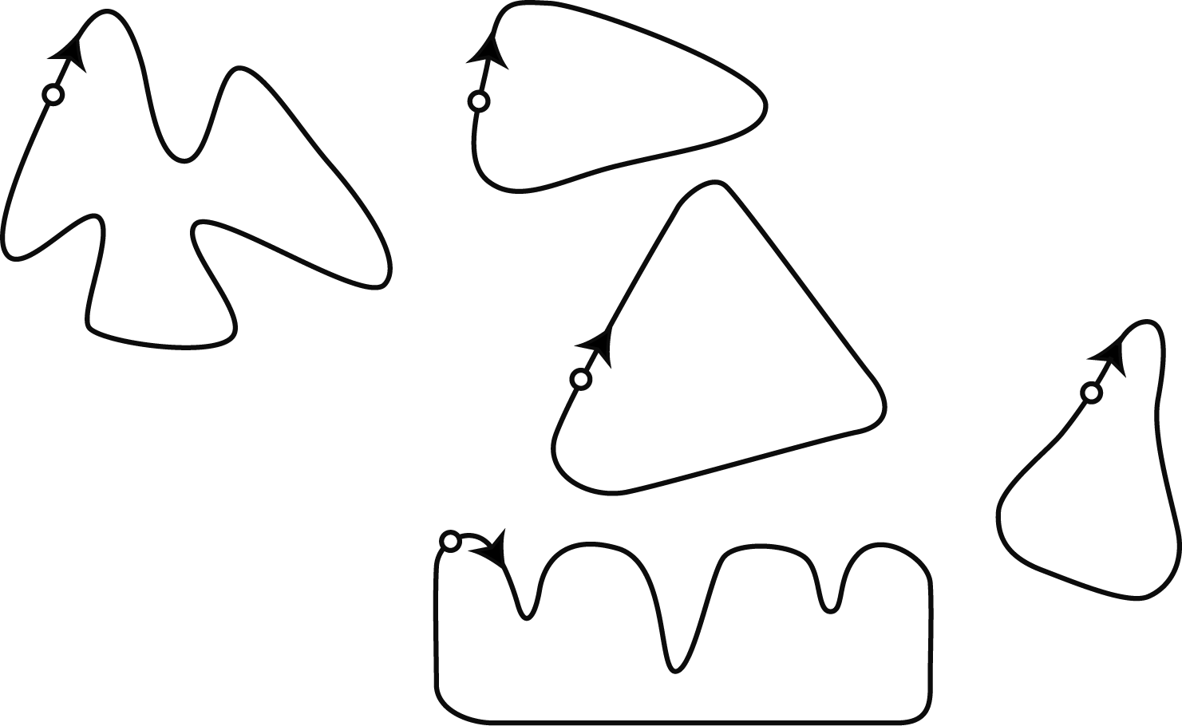
S: Starting point
AA
BA
CA
DA
EA
S A
S A
S A
S A
S A
SCORING:

Correct

B

Incorrect

Other responses.

Percentage of students answering correctly in PISA 2000:

OECD average: 29%
U.S.: 23%
Triangles

Question 1: TRIANGLES M161Q01
Question intent: Space and shape
Circle the one figure below that fits the following description.
Triangle PQR is a right triangle with right angle at R. The line RQ is less than the line PR. M is the midpoint of the line PQ and N is the midpoint of the line QR. S is a point inside the triangle. The line MN is greater than the line MS.
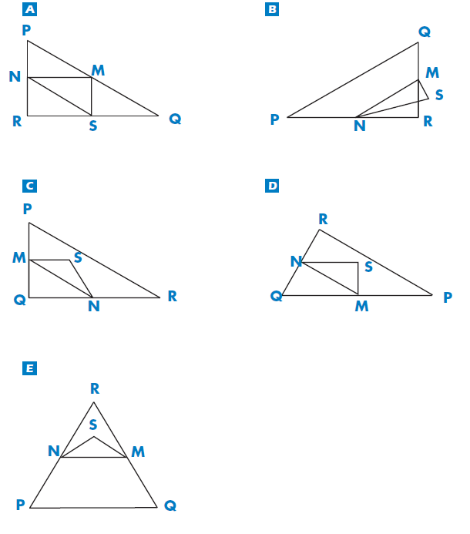

SCORING:
Percentage of students answering correctly in PISA 2000:

OECD average: 59%
U.S.: 46%
Correct

D

Incorrect

Other responses.

FARMS

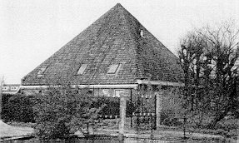
Here you see a photograph of a farmhouse with a roof in the shape of a pyramid. Below is a student’s mathematical model of the farmhouse roof with measurements added.
T
B
A
12 m
G
C
H
F
D
E
N
M
K
L
12 m
12 m
The attic floor, ABCD in the model, is a square. The beams that support the roof are the edges of a block (rectangular prism) EFGHKLMN. E is the middle of AT, F is the middle of BT, G is the middle of CT and H is the middle of DT. All the edges of the pyramid in the model have length 12 m.
Question 1: FARMS M037Q01
Question intent: Space and shape

Calculate the area of the attic floor ABCD.
The area of the attic floor ABCD = ______________ m²

SCORING:

Correct

144 (unit already given)

Incorrect

Other responses.

Percentage of students answering correctly in PISA 2000:

OECD average: 61%
U.S.: 46%

Question 2: FARMS M037Q02
Question intent: Space and shape

Calculate the length of EF, one of the horizontal edges of the block.
The length of EF = ____________ m

SCORING:

Correct

6 (unit already given)

Incorrect

Other responses.

Percentage of students answering correctly in PISA 2000:

OECD average: 55%
U.S.: 60%

CUBES
In this photograph you see six dice, labeled (a) to (f). For all dice there is a rule:
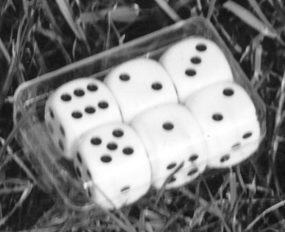
The total number of dots on two opposite faces of each die is always seven.
(d)
(b)
(a)
(f)
(c)
(e)

Question 1: CUBES M145Q01
Question intent: Space and shape

Write in each box the number of dots on the bottom face of the dice corresponding to the photograph.
(a) | (b) | (c)
(d) | (e) | (f)

SCORING:

Correct

Top row (1 5 4) Bottom Row (2 6 5). Equivalent answer shown as dice faces is also acceptable.

Incorrect

Other responses.

Percentage of students answering correctly in PISA 2000:

OECD average: 59%
U.S.: 52%

GROWING UP
Youth grows taller
In 1998 the average height of both young males and young females in the Netherlands is represented in this graph.

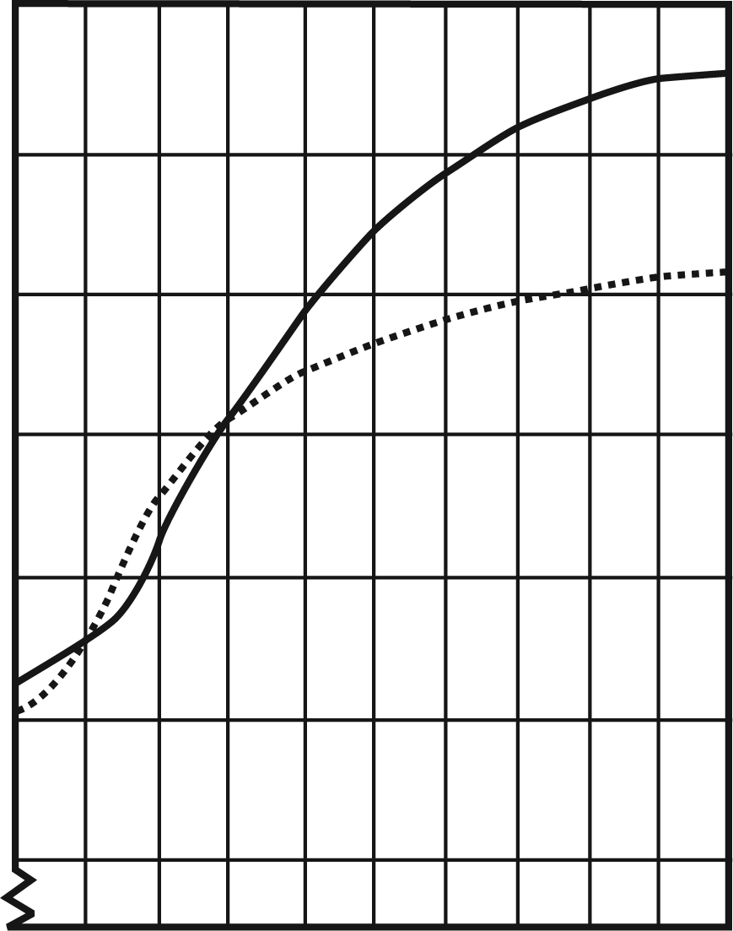
10
11
12
13
14
15
16
17
18
19
20
190
180
170
160
150
130
140
Height
(cm)
Average height of young males 1998
Average height of young females 1998
Age
(Years)

Question 1: GROWING UP M150Q01
Question intent: Change and relationships

Since 1980 the average height of 20-year-old females has increased by 2.3 cm, to 170.6 cm. What was the average height of a 20-year-old female in 1980?
Cm
SCORING:

Correct

168.3 cm (unit already given).

Incorrect

Other responses.

Percentage of students answering correctly in PISA 2000:

OECD average: 62%
U.S.: 51%
Question 2: GROWING UP M150Q02
Question intent: Change and relationships

Explain how the graph shows that on average the growth rate for girls slows down after 12 years of age.

SCORING:

Correct

The key here is that the response should refer to the “change” of the gradient of the graph for female. This can be done explicitly or implicitly.
- Refers to the reduced steepness of the curve from 12 years onwards, using daily-life language, not mathematical language.
- Refers to the reduced steepness of the curve from 12 years onwards, using mathematical language.
  - In general, if words like “gradient”, “slope”, or “rate of change” are used, regard it as using mathematical language.
- Comparing actual growth (comparison can be implicit).

Incorrect

Student indicates that female height drops below male height, but does NOT mention the steepness of the female graph or a comparison of the female growth rate before and after 12 years.

Other responses.
Percentage of students answering correctly in PISA 2000:

OECD average: 69%
U.S.: 61%

Question 3: GROWING UP M150Q03
Question intent: Change and relationships

According to this graph, on average, during which period in their life are females taller than males of the same age?

SCORING:
Fully Correct

Gives the correct interval, from 11 to 13 years.

States that girls are taller than boys when they are 11 and 12 years old. (This answer is correct in daily-life language, because it means the interval from 11 to 13).

Partially Correct

Other subsets of (11, 12, 13), not included in the full credit section.

Incorrect
Other responses.
Percentage of students answering correctly in PISA 2000:

OECD average: 46%
U.S.: 57%

Walking
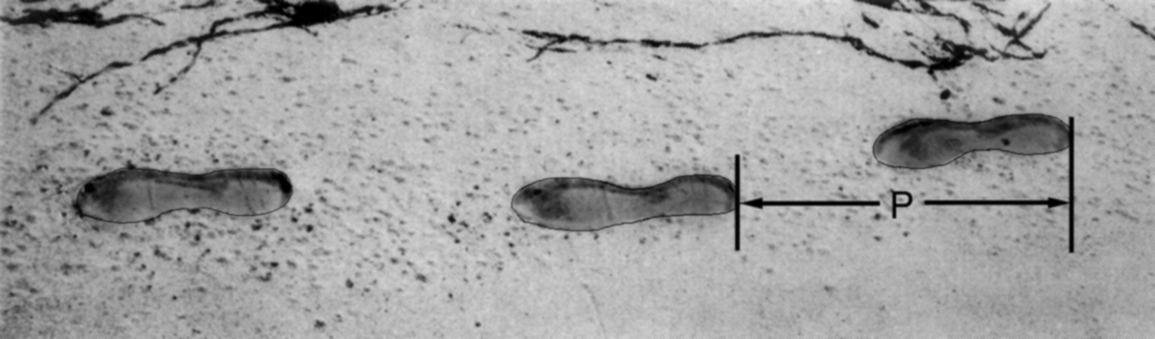
The picture shows the footprints of a man walking. The pacelength P is the distance between the rears of two consecutive footprints.
For men, the formula,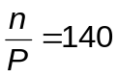, gives an approximate relationship between n and P where,
n = number of steps per minute, and
P = pacelength in meters

Question 1: WALKING M124Q01

Question intent: Change and relationships

If the formula applies to Heiko’s walking and Heiko takes 70 steps per minute, what is Heiko’s pacelength? Show your work.

SCORING:

Correct

0.5 m or 50 cm, ½ (unit not required)

70/ p = 140
70 = 140 p
p=70/140
p = 0.5

Incorrect

Other responses.

Percentage of students answering correctly in PISA 2000:

OECD average: 34%
U.S.: 26%

Question 2: WALKING M124Q03

Question intent: Change and relationships

Bernard knows his pacelength is 0.80 meters. The formula applies to Bernard’s walking.

Calculate Bernard’s walking speed in meters per minute and in kilometers per hour.

Show your work.

SCORING:

Fully Correct

Correct answers (unit not required) for both meters/minute and km/hour:

n = 140 x .80 = 112.
Per minute he walks 112 x .80 meters = 89.6 meters.
His speed is 89.6 meters per minute.
So his speed is 5.38 or 5.4 km/hr.

As long as both correct answers are given (89.6 and 5.4), whether working out is shown or not.
Note that errors due to rounding are acceptable. For example, 90 meters per minute and 5.3 km/hr (89 X 60) are acceptable.

- 89.6, 5.4.
- 90, 5.376 km/h.
- 89.8, 5376 m/hour.

Partially Correct

Fails to multiply by 0.80 to convert from steps per minute to meters per minute. For example, his speed is 112 meters per minute and 6.72 km/hr.
- 112, 6.72 km/h.

The speed in meters per minute correct (89.6 meters per minute) but conversion to kilometers per hour incorrect or missing.
- 89.6 meters/minute, 8960 km/hr.
- 89.6, 5376.
- 89.6, 53.76.
- 89.6, 0.087 km/h.
- 89.6, 1.49 km/h.

Correct method (explicitly shown) with minor calculation error(s). No answers correct.
- n=140 x .8 = 1120; 1120 x 0.8 = 896. He walks 896 m/min, 53.76km/h.
- n=140 x .8 = 116; 116 x 0.8 =92.8. 92.8 m/min -> 5.57km/h.
Only 5.4 km/hr is given, but not 89.6 meters/minute (intermediate calculations not shown).
- 5.4.
- 5.376 km/h.
- 5376 m/h.

Partially Correct

n = 140 x .80 = 112. No further working out is shown or incorrect working out from this point.
- 112.
- n=112, 0.112 km/h.
- n=112, 1120 km/h.
- 112 m/min, 504 km/h.

Incorrect

Other responses.

Percentage of students answering correctly in PISA 2000:

OECD average: 19%
U.S.: 18%

ROBBERIES
A TV reporter showed this graph and said:
“The graph shows that there is a huge increase in the number of robberies from 1998 to 1999.”
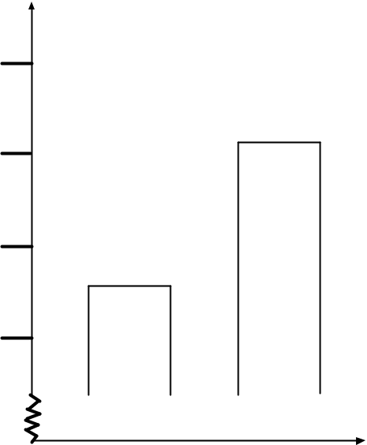
Number of robberies per year
Year 1999
Year 1998
505
510
515
520

Question 1: ROBBERIES M179Q01
Question intent: Uncertainty

Do you consider the reporter’s statement to be a reasonable interpretation of the graph? Give explanation to support your answer.

SCORING:
Fully Correct

No, not reasonable. Focuses on the fact that only a small part of the graph is shown.
No, not reasonable. Contains correct arguments in terms of ratio or percentage increase.
Trend data is required before a judgement can be made.
Partially Correct

Note: As the scale on the graph is not that clear, accept between 5 and 15 for the increase of the exact number of robberies.

No, not reasonable, but explanation lacks detail.
No, not reasonable, with correct method but with minor computational errors.
Incorrect
No, with insufficient or incorrect explanation.
Yes, focuses on the appearance of the graph and mentions the number of robberies doubled.
Yes, with no explanation or other explanations than above.
Other responses.
Percentage of students answering correctly in PISA 2000:

OECD average: 27%
U.S.: 30%

CARPENTER

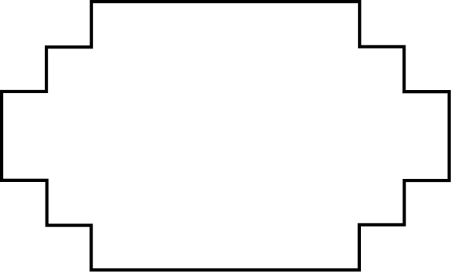
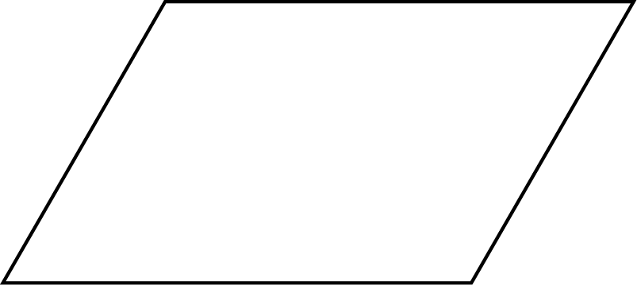
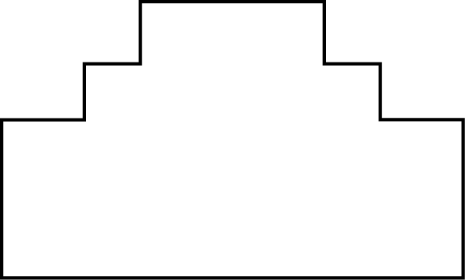
A carpenter has 32 meters of timber and wants to make a border around a garden bed. He is considering the following designs for the garden bed.
10 m
6 m
10 m
10 m
10 m
6 m
6 m
6 m
A
B
D
C
Question 1: Carpenter M266Q01
Question intent: Space and shape
Circle either “Yes” or “No” for each design to indicate whether the garden bed can be made with 32 meters of timber.
Garden bed design | Using this design, can the garden bed be made with 32 meters of timber?
Design A | Yes / No
Design B | Yes / No
Design C | Yes / No
Design D | Yes / No

SCORING:

Correct

All four correct: Yes, No, Yes, Yes in that order.

Incorrect

Two or fewer correct.
Percentage of students answering correctly in PISA 2000:

OECD average: 20%
U.S.: 13%

internet Relay chat
Mark (from Sydney, Australia) and Hans (from Berlin, Germany) often “chat” with each other on the Internet. They have to log on to the Internet at the same time to be able to chat.
To find a suitable time to chat, Mark looked up a chart of world times and found the following:
Greenwich 12 Midnight
Berlin 1:00 AM
Sydney 10:00 AM

Question 1: INTERNET RELAY CHAT M402Q01 - 019
Question intent: Change and relationships

At 7:00 PM in Sydney, what time is it in Berlin?
Answer:

SCORING:

Correct

10 AM or 10:00.

Incorrect

Other responses.

Percentage of students answering correctly in PISA 2003:

OECD average: 54%
U.S.: 46%

Question 2: INTERNET RELAY CHAT M402Q02 - 019
Question intent: Change and relationships

Mark and Hans are not able to chat between 9:00 AM and 4:30 PM their local time, since they have to go to school. Also, from 11:00 PM till 7:00 AM their local time they won’t be able to chat because they will be sleeping.
When would be a good time for Mark and Hans to chat? Write the local times in the table.
Place | Time
Sydney
Berlin

SCORING:

Correct

Any time or interval of time satisfying the 9 hours time difference and taken from one of these intervals:

- Sydney: 4:30 PM – 6:00 PM; Berlin: 7:30 AM – 9:00 AM
- Sydney: 7:00 AM – 8:00 AM; Berlin: 10:00 PM – 11:00 PM
- Sydney 17:00, Berlin 8:00.
Note: If an interval is given, the entire interval must satisfy the constraints. Also, if morning (AM) or evening (PM) is not specified, but the times could otherwise be regarded as correct, the response should be given the benefit of the doubt, and counted as correct.
Incorrect
Other responses, including one time correct, but corresponding time incorrect.

Percentage of students answering correctly in PISA 2003:

OECD average: 29%
U.S.: 28%
exchange rate
Mei-Ling from Singapore was preparing to go to South Africa for 3 months as an exchange student. She needed to change some Singapore dollars (SGD) into South African rand (ZAR).

Question 1: EXCHANGE RATE M413Q01 - 019
Question intent: Quantity

Mei-Ling found out that the exchange rate between Singapore dollars and South African rand was:
1 SGD = 4.2 ZAR
Mei-Ling changed 3000 Singapore dollars into South African rand at this exchange rate.
How much money in South African rand did Mei-Ling get?
Answer:
SCORING:

Correct

12 600 ZAR (unit not required).

Incorrect

Other responses.

Percentage of students answering correctly in PISA 2003:

OECD average: 80%
U.S.: 54%

Question 2: EXCHANGE RATE M413Q02 - 019
Question intent: Quantity

On returning to Singapore after 3 months, Mei-Ling had 3 900 ZAR left. She changed this back to Singapore dollars, noting that the exchange rate had changed to:
1 SGD = 4.0 ZAR
How much money in Singapore dollars did Mei-Ling get?
Answer:
SCORING:
Correct

975 SGD (unit not required).

Incorrect

Other responses.

Percentage of students answering correctly in PISA 2003:

OECD average: 74%
U.S.: 68%

Question 3: EXCHANGE RATE M413Q03 - 01 02 11 99
Question intent: Quantity

During these 3 months the exchange rate had changed from 4.2 to 4.0 ZAR per SGD.
Was it in Mei-Ling’s favor that the exchange rate now was 4.0 ZAR instead of 4.2 ZAR, when she changed her South African rand back to Singapore dollars? Give an explanation to support your answer.
SCORING:
Correct
“Yes,” with adequate explanation.
- Yes, by the lower exchange rate (for 1 SGD) Mei-Ling will get more Singapore dollars for her South African rand.
- Yes, 4.2 ZAR for one dollar would have resulted in 929 ZAR. [Note: student wrote ZAR instead of SGD, but clearly the correct calculation and comparison have been carried out and this error can be ignored]
- Yes, because she received 4.2 ZAR for 1 SGD, and now she has to pay only 4.0 ZAR to get 1 SGD.
- Yes, because it is 0.2 ZAR cheaper for every SGD.
- Yes, because when you divide by 4.2 the outcome is smaller than when you divide by 4.
- Yes, it was in her favor because if it didn’t go down she would have got about $50 less.
Incorrect
“Yes,” with no explanation or with inadequate explanation.
- Yes, a lower exchange rate is better.
- Yes it was in Mei-Ling’s favor, because if the ZAR goes down, then she will have more money to exchange into SGD.
- Yes it was in Mei-Ling’s favor.
Other responses.
Percentage of students answering correctly in PISA 2003:

OECD average: 41%
U.S.: 37%
exports

The graphics below show information about exports from Zedland, a country that uses zeds as its currency.
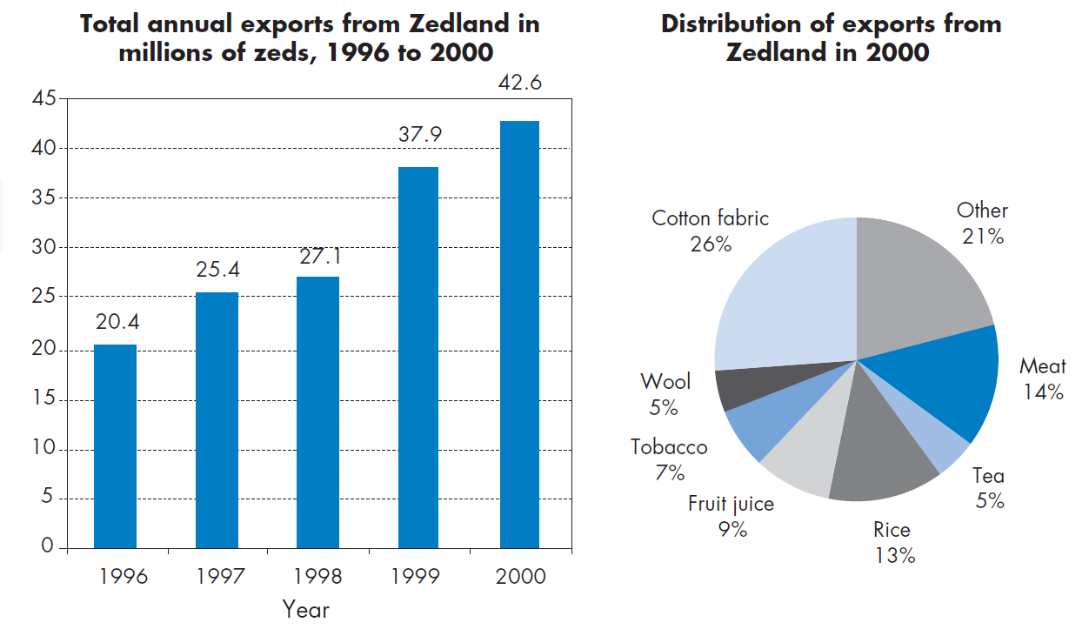

  - : EXPORTS M438Q01 - 019
Question intent: Uncertainty

What was the total value (in millions of zeds) of exports from Zedland in 1998?
Answer:

SCORING:

Correct
27.1 million zeds or 27 100 000 zeds or 27.1 (unit not required).
Incorrect
Other responses.

Percentage of students answering correctly in PISA 2003:

OECD average: 79%
U.S.: 41%

Question 2: EXPORTS M438Q02
Question intent: Uncertainty

What was the value of fruit juice exported from Zedland in 2000?
- 1.8 million zeds.
- 2.3 million zeds.
- 2.4 million zeds.
- 3.4 million zeds.
- 3.8 million zeds.

SCORING:
Correct
Answer E. 3.8 million zeds.
Incorrect
Other responses.

Percentage of students answering correctly in PISA 2003:

OECD average: 49%
U.S.: 43%
Colored Candies

Robert’s mother lets him pick one candy from a bag. He can’t see the candies. The number of candies of each color in the bag is shown in the following graph.

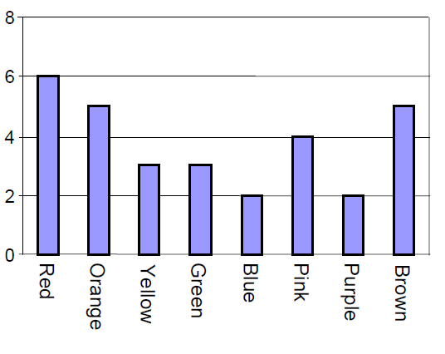

Question 1: COLORED CANDIES M467Q01

Question intent: Uncertainty

What is the probability that Robert will pick a red candy?
A 10%
B 20%
C 25%
D 50%

SCORING:

Correct

Answer B. 20%.

Incorrect

Other responses.
Percentage of students answering correctly in PISA 2003:

OECD average: 51%
U.S.: 53%

SCIENCE TESTS
In Mei Lin’s school, her science teacher gives tests that are marked out of 100. Mei
Lin has an average of 60 points on her first four Science tests. On the fifth test she got 80 points.

Question 1: SCIENCE TESTS M468Q01

Question intent: Uncertainty

What is the average of Mei Lin’s points in Science after all five tests?

Average: .................................................

SCORING:

Correct

64.

Incorrect

Other responses.

Percentage of students answering correctly in PISA 2003:

OECD average: 47%
U.S.: 55%

bookshelves

To complete one set of bookshelves a carpenter needs the following components:
4 long wooden panels,
6 short wooden panels,
12 small clips,
2 large clips and
14 screws.
The carpenter has in stock 26 long wooden panels, 33 short wooden panels, 200 small clips, 20 large clips and 510 screws.

Question 1: BOOKSHELVES M484Q01
Question intent: Quantity

How many sets of bookshelves can the carpenter make?
Answer:

SCORING:
Correct
5.
Incorrect
Other responses.

Percentage of students answering correctly in PISA 2003:

OECD average: 61%
U.S.: 57%

LITTER

For a homework assignment on the environment, students collected information on the decomposition time of several types of litter that people throw away:

Type of Litter | Decomposition time
Banana peel | 1–3 years
Orange peel | 1–3 years
Cardboard boxes | 0.5 year
Chewing gum | 20–25 years
Newspapers | A few days
Polystyrene cups | Over 100 years

A student thinks of displaying the results in a bar graph.

Question 1: LITTER M505Q01 - 0 1 9

Question intent: Uncertainty

Give one reason why a bar graph is unsuitable for displaying these data.
……………………………………………………………………………………………….

SCORING:

Correct

Reason focuses on big variance in data.
- The difference in the lengths of the bars of the bar graph would be too big.
- If you make a bar with length 10 centimeters for polystyrene, the one for cardboard boxes would be 0.05 centimeters.

OR

Reason focuses on the variability of the data for some categories.
- The length of the bar for “polystyrene cups” is undetermined.
- You cannot make one bar for 1–3 years or one bar for 20–25 years.

Incorrect

Other responses.

Percentage of students answering correctly in PISA 2003:

OECD average: 52%
U.S.: 20%

earthquake
A documentary was broadcast about earthquakes and how often earthquakes occur.
It included a discussion about the predictability of earthquakes.

A geologist stated: “In the next twenty years, the chance that an earthquake will occur in Zed City is two out of three.”

Question 1: EARTHQUAKE M509Q01
Question intent: Uncertainty

Which of the following best reflects the meaning of the geologist’s statement?
- 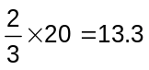, so between 13 and 14 years from now there will be an earthquake in Zed City.
- is more than , so you can be sure there will be an earthquake in Zed City at some time during the next 20 years.
- The likelihood that there will be an earthquake in Zed City at some time during the next 20 years is higher than the likelihood of no earthquake.
- You cannot tell what will happen, because nobody can be sure when an earthquake will occur.

SCORING:

Correct

Answer C. The likelihood that there will be an earthquake in Zed City at some time during the next 20 years is higher than the likelihood of no earthquake.

Incorrect

Other responses.

Percentage of students answering correctly in PISA 2003:

OECD average: 47%
U.S.: 53%

CHOICES

In a pizza restaurant, you can get a basic pizza with two toppings: cheese and tomato. You can also make up your own pizza with extra toppings. You can choose from four different extra toppings: olives, ham, mushrooms and salami.

Ross wants to order a pizza with two different extra toppings.

Question 1: CHOICES M510Q01

Question intent: Quantity

How many different combinations can Ross choose from?

Answer: .................................................. combinations.

SCORING:

Correct

6.

Incorrect

Other responses.

Percentage of students answering correctly in PISA 2003:

OECD average: 49%
U.S.: 44%

TEST SCORES

The diagram below shows the results on a Science test for two groups, labeled as
Group A and Group B.

The mean score for Group A is 62.0 and the mean for Group B is 64.5. Students pass this test when their score is 50 or above.

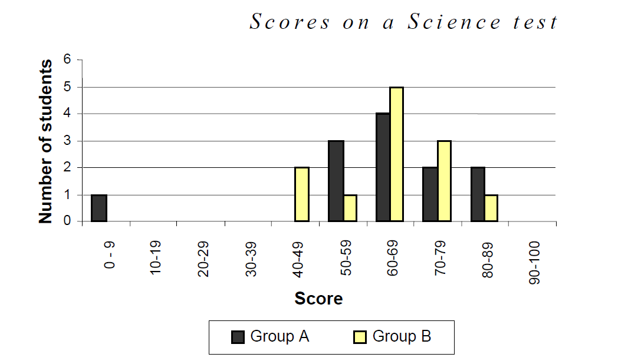

Looking at the diagram, the teacher claims that Group B did better than Group A in this test.

The students in Group A don’t agree with their teacher. They try to convince the teacher that Group B may not necessarily have done better.

Question 1: TEST SCORES M513Q01 - 0 1 9
Question intent: Uncertainty

Give one mathematical argument, using the graph that the students in Group A could use.

SCORING:

Correct

One valid argument is given. Valid arguments could relate to the number of students passing, the disproportionate influence of the outlier, or the number of students with scores in the highest level.
- More students in Group A than in Group B passed the test.
- If you ignore the weakest Group A student, the students in Group A do better than those in Group B.
- More Group A students than Group B students scored 80 or over.

Incorrect

Other responses, including responses with no mathematical reasons, or wrong mathematical reasons, or responses that simply describe differences but are not valid arguments that Group B may not have done better.
- Group A students are normally better than Group B students in science. This test result is just a coincidence.
- Because the difference between the highest and lowest scores is smaller for Group B than for Group A.
- Group A has better score results in the 80-89 range and the 50-59 range.
- Group A has a larger inter-quartile range than Group B.

Percentage of students answering correctly in PISA 2003:

OECD average: 33%
U.S.: 40%

Skateboard

Eric is a great skateboard fan. He visits a shop named SKATERS to check some prices.

At this shop you can buy a complete board. Or you can buy a deck, a set of 4 wheels, a set of 2 trucks and a set of hardware, and assemble your own board.

The prices for the shop’s products are:

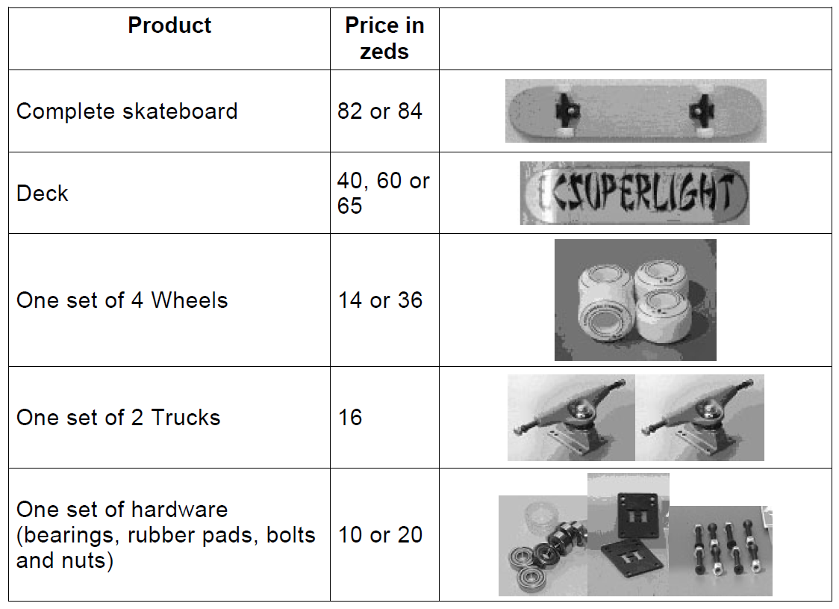

Question 1: SKATEBOARD M520Q01a M520Q01b

Question intent: Quantity

Eric wants to assemble his own skateboard. What is the minimum price and the maximum price in this shop for self-assembled skateboards?

(a) Minimum price: ................................. zeds.

(b) Maximum price: ................................ zeds.

SCORING:

Fully Correct

Both the minimum (80) and the maximum (137) correct.

Partially Correct

Only the minimum (80) correct or only the maximum (137) correct.

Incorrect

Other responses.

Percentage of students answering correctly in PISA 2003:

OECD average: 72%
U.S.: 62%

Question 2: SKATEBOARD M520Q02

Question intent: Quantity

The shop offers three different decks, two different sets of wheels and two different sets of hardware. There is only one choice for a set of trucks.

How many different skateboards can Eric construct?

A 6
B 8
C 10
D 12

SCORING:

Correct

Answer D. 12.

Incorrect

Other responses.

Percentage of students answering correctly in PISA 2003:

OECD average: 46%
U.S.: 50%

Question 3: SKATEBOARD M520Q03

Question intent: Quantity

Eric has 120 zeds to spend and wants to buy the most expensive skateboard he can afford.

How much money can Eric afford to spend on each of the 4 parts? Put your answer in the table below.

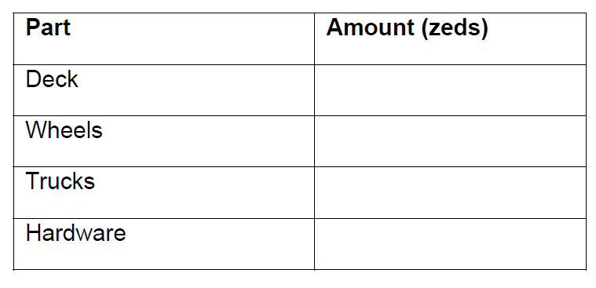

SCORING:

Correct

65 zeds on a deck, 14 on wheels, 16 on trucks and 20 on hardware.

Incorrect

Other responses.

Percentage of students answering correctly in PISA 2003:

OECD average: 50%
U.S.: 46%

staircase

The diagram below illustrates a staircase with 14 steps and a total height of 252 cm:

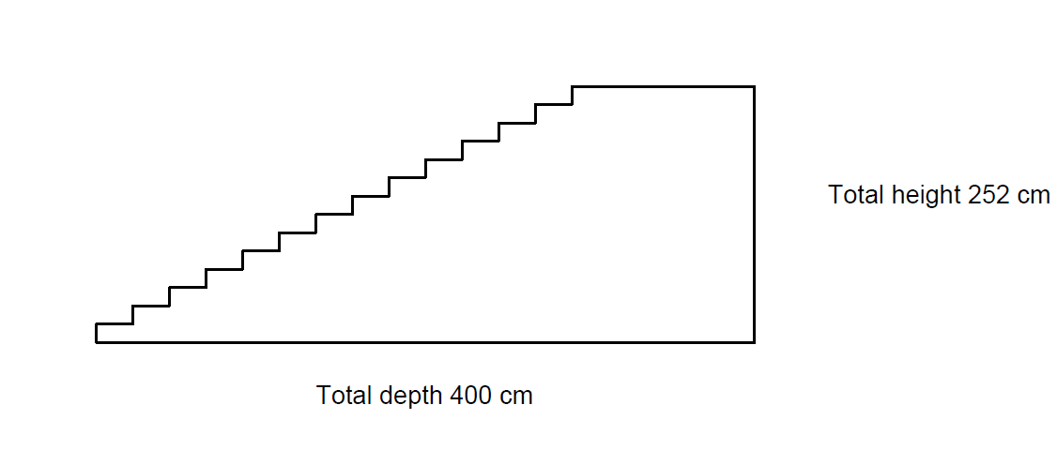

Question 1: STAIRCASE M547Q01

Question intent: Space and shape

What is the height of each of the 14 steps?

Height: .................................................... cm.

SCORING:

Correct

18.

Incorrect

Other responses.

Percentage of students answering correctly in PISA 2003:

OECD average: 78%
U.S.: 70%

NUMBER CUBES

On the right, there is a picture of two dice.
Dice are special number cubes for which the following rule applies:
The total number of dots on two opposite faces is always seven.
You can make a simple number cube by cutting, folding and gluing cardboard. This can be done in many ways. In the figure below you can see four cuttings that can be used to make cubes, with dots on the sides.

Question 1: NUMBER CUBES M555Q02
Question intent: Space and shape

Which of the following shapes can be folded together to form a cube that obeys the rule that the sum of opposite faces is 7? For each shape, circle either “Yes” or “No” in the table below.
I
II
III
IV
Shape | Obeys the rule that the sum of opposite faces is 7?
I | Yes / No
II | Yes / No
III | Yes / No
IV | Yes / No

SCORING:

Correct

No, Yes, Yes, No, in that order.

Incorrect

Other responses.

Percentage of students answering correctly in PISA 2003:

OECD average: 63%
U.S.: 53%

SUPPORT FOR THE PRESIDENT

In Zedland, opinion polls were conducted to find out the level of support for the President in the forthcoming election. Four newspaper publishers did separate nationwide polls. The results for the four newspaper polls are shown below:

Newspaper 1: 36.5% (poll conducted on January 6, with a sample of 500 randomly selected citizens with voting rights)

Newspaper 2: 41.0% (poll conducted on January 20, with a sample of 500 randomly selected citizens with voting rights)

Newspaper 3: 39.0% (poll conducted on January 20, with a sample of 1000 randomly selected citizens with voting rights)

Newspaper 4: 44.5% (poll conducted on January 20, with 1000 readers phoning in to vote).

Question 1: SUPPORT FOR THE PRESIDENT M702Q01 - 0 1 2 9

Question intent: Uncertainty

Which newspaper’s result is likely to be the best for predicting the level of support for the President if the election is held on January 25? Give two reasons to support your answer.

SCORING:

Correct

Newspaper 3. The poll is more recent, with larger sample size, a random selection of the sample, and only voters were asked. (Give at least two reasons). Additional information (including irrelevant or incorrect information) should be ignored.
- Newspaper 3, because they have selected more citizens randomly with voting rights.
- Newspaper 3 because it has asked 1000 people, randomly selected, and the date is closer to the election date so the voters have less time to change their mind.
- Newspaper 3 because they were randomly selected and they had voting rights.
- Newspaper 3 because it surveyed more people closer to the date.
- Newspaper 3 because the 1000 people were randomly selected.

Incorrect

Other responses.
Percentage of students answering correctly in PISA 2003:

OECD average: 36%
U.S.: 34%

the best caR

A car magazine uses a rating system to evaluate new cars, and gives the award of “The Car of the Year” to the car with the highest total score. Five new cars are being evaluated, and their ratings are shown in the table.

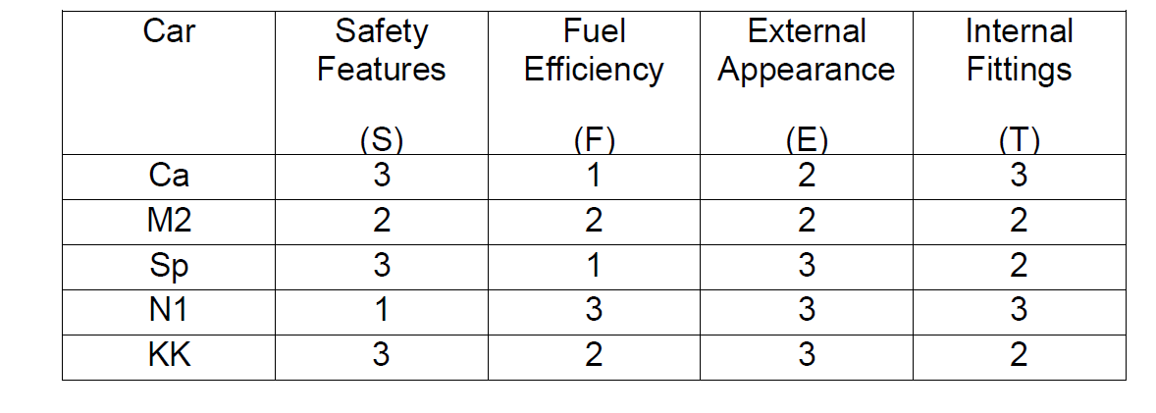
The ratings are interpreted as follows:

3 points = Excellent
2 points = Good
1 point = Fair

Question 1: THE BEST CAR M704Q01

Question intent: Change and relationships

To calculate the total score for a car, the car magazine uses the following rule, which is a weighted sum of the individual score points:

Total Score = (3 x S) + F + E + T

Calculate the total score for Car “Ca”. Write your answer in the space below.

Total score for “Ca”: ...............................

SCORING:

Correct

15 points.

Incorrect

Other responses.

Percentage of students answering correctly in PISA 2003:

OECD average: 73%
U.S.: 75%

Question 2: THE BEST CAR M704Q02

Question intent: Change and relationships

The manufacturer of car “Ca” thought the rule for the total score was unfair.

Write down a rule for calculating the total score so that Car “Ca” will be the winner.

Your rule should include all four of the variables, and you should write down your rule by filling in positive numbers in the four spaces in the equation below.

Total score = ………× S + ………× F + ………× E + ………× T.

SCORING:

Correct

Correct rule that will make “Ca” the winner.

Incorrect

Other responses.

Percentage of students answering correctly in PISA 2003:

OECD average: 26%
U.S.: 20%

step pattern

Robert builds a step pattern using squares. Here are the stages he follows.
Stage 1
Stage 2
Stage 3
As you can see, he uses one square for Stage 1, three squares for Stage 2 and six for Stage 3.

Question 1: STEP PATTERN M806Q01
Question intent: Quantity

How many squares should he use for the fourth stage?
Answer: squares.

SCORING:

Correct

10.

Incorrect

Other responses.

Percentage of students answering correctly in PISA 2003:

OECD average: 67%
U.S.: 60%

forecast of rainfall
Question 1: FORECAST OF RAINFALL M710Q01
Question intent: Uncertainty

On a particular day, the weather forecast predicts that from 12 noon to 6 pm the chance of rainfall is 30%.
Which of the following statements is the best interpretation of this forecast?
- 30% of the land in the forecast area will get rain.
- 30% of the 6 hours (a total of 108 minutes) will have rain.
- For the people in that area, 30 out of every 100 people will experience rain.
- If the same prediction was given for 100 days, then about 30 days out of the 100 days will have rain.
- The amount of rain will be 30% of a heavy rainfall (as measured by rainfall per unit time).

SCORING:

Correct

Answer D. If the same prediction was given for 100 days, then about 30 days out of the 100 days will have rain.

Incorrect

Other responses.

Percentage of students answering correctly in PISA 2003:

OECD average: 34%
U.S.: 31%

