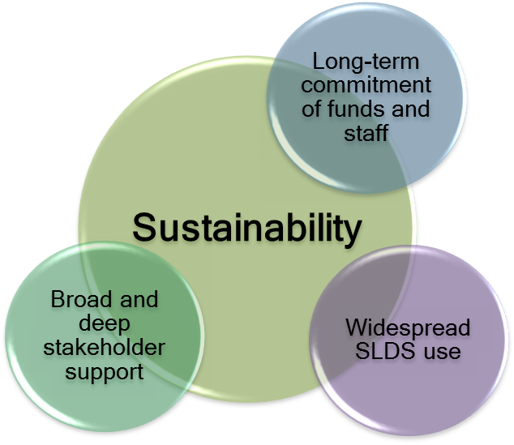Purpose:
This self-assessment tool is designed to support states as they examine their ability to sustain their state longitudinal data system (SLDS). It is meant to provide states with a reflective process for identifying areas of strength and areas in need of improvement, as well as short- and long-term goals.
State Instructions:
- Respond to the questions presented in each of the sections (A-D). Note: This is only for your use, so be as honest as possible.
- In the “Quick Check” of each section, reflect on your state responses and identify where the state has been successful and where there are potential needs in order to move the effort forward.
- Use the final section (E) to review your responses to previous questions in order to determine next steps for your state.
What makes an SLDS sustainable? A sustainable system has broad and deep stakeholder support, widespread use, as well as long-term commitments of funds and staff.

Section A: Stakeholder Support: How broad and deep is the stakeholder support for your system?
Questions:
- Where is support for your SLDS strongest? For each question, rate support/involvement of each stakeholder group from 1-4 (1=low; 4=high) or N/A. In the final column, insert the sum of all the columns to the left to estimate total support/involvement.
Stakeholder Support | Legis-lature | Governor’s Office | Agency Executives | Agency Staff | P-20W+ Partners | Local Administrators | Teach-ers | Research-ers | General Public | Other | Total
- How aware are stakeholders of your system? | d |  |  |  |  |  |  |  |  | d | d
- How well do stakeholders understand the system?
- How strongly do stakeholders support the system?
- If you have a stakeholder advisory group, how involved are stakeholders in that group?
Total = /40
- How is your state working to bolster and sustain stakeholder support? Check the appropriate box in response to each question below.
Stakeholder Support | Yes, Completed | Yes, But Would Like to Improve | Planning | No | Unsure
- Have you tracked stakeholder awareness of your system?
- Have you documented your stakeholders’ support for the system?
- Do you have a stakeholder committee/advisory group?
- Does state legislation support the use of your system? If not, is this something your state has considered?
- Have you provided appropriate methods of reports or dashboards for your stakeholders?
- Do you brand all reports/presentations based on SLDS data with the state SLDS logo so people see that the SLDS is providing useful information?
- Do you have a communications and stakeholder engagement plan?

Quick Check: Where has your state been successful with stakeholder support? What is still needed to move your state forward in effectively ensuring broad and deep stakeholder support?
Section B: SLDS Use: How widespread is the use of your SLDS?
Questions:
- In your opinion, how widespread is the use of your system? Rate each stakeholder group from 1-4 (1=low; 4=high) or N/A.
SLDS Use | Legis-lature | Governor’s Office | Agency Executives | Agency Staff | P-20W+ Partners | Local Administrators | Teach-ers | Research-ers | General Public | Other | Total
- Who are your SLDS’s intended users?
- How frequent is the use of your system by each stakeholder group?
Total = /40
- Which system components are used and how are they applied?
  - Which system components would you like to see used more regularly or applied differently?
  - What are some ways to promote these components in the way you would like to see them used?

- Do you offer professional development (PD)/training around the system/tools?
  - What PD/training opportunities are available in your state?
  - How is the training differentiated for different users (e.g., teachers as opposed to legislators)?
  - Which stakeholders participate in the trainings?

  - How have you tracked the effectiveness of the trainings?

- How well has the SLDS met reporting and decisionmaking needs?
  - How is your state rating and documenting the helpfulness of the reporting and analysis tools?
  - How has the system made data adequately available and accessible?
  - How does the state know if users are getting the data they need?

- Overall, how does your state ensure widespread usage of your system? Check the appropriate box in response to each question below.
SLDS Use | Yes, Completed | Yes, But Would Like to Improve | Planning | No | Unsure
- Does your state clearly articulate who the system was intended to be used by?
- Does your state document the stakeholders and how often they use the system?
- Does your state know how stakeholders are using the system?
- Does your state provide training?
- Does your state document how effectively the system has been used to make decisions?

Quick Check: Where has your state been successful with SLDS use? What is needed to institutionalize usage of your system?
Section C: Financial Support: How strong is the financial support for your SLDS?
Questions:
- What are your current sources of financial support? Circle all that apply.
  - SLDS grant funds
  - State funds
  - Foundational support
  - Separate program areas (assessment, Individuals with Disabilities Education Act, Limited English Proficient, Title I, etc.)
  - State-level technology bonds
  - Universities and higher education research institutions
  - Partner agencies
  - Business/private sources
  - Other (please explain): ______________________________________________________

- What are your greatest expenses?
  - Staff
  - Vendors
  - Equipment
  - Training
  - Other (please explain): ______________________________________________________

- Does the state know how much it will cost to support and maintain the system?
  - Who will maintain your system, a vendor or in-house staff?
  - How often will hardware and software need to be updated?
  - How will documentation be updated and kept current?
  - How much change, including program changes and the addition of new data elements, will your system accommodate?
  - Will you continue to provide training after the grant? How regularly?
  - How have you marketed your system? How will you continue to market the system?

- Where could you look for long-term sources of support? Circle all that apply.
  - SLDS grant funds
  - State funds
  - Foundational support
  - Separate program areas (assessment, Individuals with Disabilities Education Act, Limited English Proficient, Title I)
  - State-level technology bonds
  - Universities and higher education research institutions
  - Partner agencies
  - Business/private sources
  - Other (please explain): ______________________________________________________

Financial Support | Yes, Completed | Yes, But Would Like to Improve | Planning | No | Unsure
- Do you know all the financial sources of support for the SLDS?
- Do you have additional financial supports for the SLDS beyond federal funding?
- Does the state know how much it will cost to support and maintain the system?
- Do you have a plan for securing long-term sources of funding?

Quick Check: Where has your state been successful in financial support? How might you expand your sources of financial support?
Section D: Return on Investment (ROI): Are you defining, measuring, recording, and demonstrating success?
Questions:
- What does ROI mean for your SLDS?

- Has your state/LEA saved money/time in any of the following ways? Circle all that apply.
  - Tracking duplicative enrollments
  - Statewide SISs and/or for data/data use services
  - Reduced LEA reporting burden
  - Electronic, rather than paper, transcripts
  - Better-targeted PD opportunities through linking teacher qualification data to student achievement
  - Online teacher certification system
  - Other (please explain): ______________________________________________________

- How are you measuring your ROI? How do you determine if there is added value to the work you are doing? Please elaborate.

- How are you communicating return on investment with your stakeholders?

Return on Investment | Yes, Completed | Yes, But Would Like to Improve | Planning | No | Unsure
- Does your state understand the value of capturing ROI?
- Is your state recording your state’s return on investment?
- Does your state capture how operations have been made more efficient?
- Did your state plan on communicating ROI with stakeholders?

Quick Check: Where has your state been successful capturing ROI? How can your state begin to demonstrate its SLDS successes?
Section E: Next Steps: Planning for Sustainability
Questions:
- Does your state have a sustainability plan?
  - If so, what does it include?
    - Are there any gaps in your current plan and the needs of your state?

  - If not, are you in the process of/planning to develop a plan?

- What TA resources would be helpful to you in planning for sustainability? Circle all that apply.
  - Sample sustainability plans
  - Sustainability plan development tools
  - ROI measures
  - Best practices and lessons learned
  - Work group
  - Other (please explain): ______________________________________________________

- What are the action steps when you return to your state?
Action Item Due Date Assigned To

Quick Check: Where has your state been successful planning for sustainability? What is needed to move your state forward in sustaining its system?

For more on engaging stakeholders, see “Stakeholder Communication,” an SLDS Best Practice Brief, available at http://nces.ed.gov/programs/slds/pdf/best_practices.pdf or in the Public Domain Clearinghouse via https://nces.grads360.org.
For more on sources of support for your SLDS, see “Alternative Sources of Support for SLDS Work,” an SLDS Best Practice Brief, available at http://nces.ed.gov/programs/slds/pdf/best_practices2b.pdf or in the Public Domain Clearinghouse via https://nces.grads360.org. Assumes teacher-student link, and teacher qualification data, including courses, major, postsecondary institution, etc.
Assumes teacher-student link, and teacher qualification data, including courses, major, postsecondary institution, etc.

