NOTES to be used in presentation*

Common Core of Data (CCD) Demonstration July 28, 2011

- CCD is the Department of Education’s primary database for describing public elementary and secondary education in the United States.
- CCD is a comprehensive, annual, national database of all public elementary and secondary schools and school districts. It contains data that are designed to be comparable across all states. (Shown on Screen 1)
- CCD Data is available is several forms:
  - As full files that are available as flat files with SPSS or SAS code- (School District data files are shown on screen 2).
  - Schools and school districts can be accessed through the school and district locators (Shown in screen 3).
  - Through the Elementary/Secondary Information System (ELSI). (Shown in Screen 4.) This tool provides a view of selected CCD data based on the most current year.
  - CCD-Build-a-Table tool (BAT). This tool is the subject of this presentation.

*Notes will not be distributed and overhead slides will not be used.
Screen 1- CCD Data overview
Screen 2- CCD Data- School District Flat File Listing
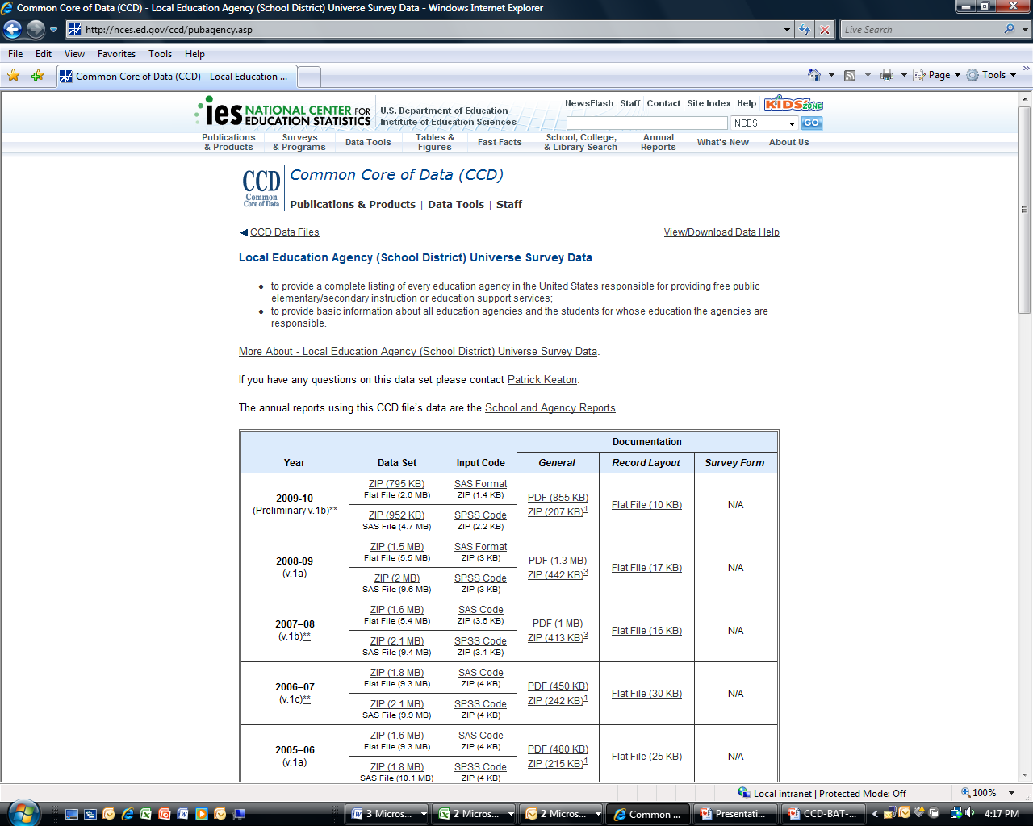
NCES SEARCH TOOLS
Screen 3 - School and School District and other LOCATORS

Common Core of Data (CCD) and Build-a-Table (BAT)
Tool Demonstration
July 28, 2011
Carl M. Schmitt
Carl.schmitt@ed.gov
202-502-7350
The following pages illustrate the content and topics that will be covered in the demonstration of the BAT
- BAT is an online tool designed by NCES to provide access to all CCD data. With this tool, it is possible to find:
- a particular school, school district, county, etc., and the corresponding desired descriptive information
- descriptive information about a single school, all schools in a district, all schools in a state
- descriptive information about all school districts, counties, statistical areas, and states
Goals of this presentation
- You will learn about the longitudinal nature of the CCD data files
- You will learn how to select variables
- You will learn to use filters to refine and customize BAT tables
- You will learn how to download and save tables
- You will be aware of the uses and limitations of the BAT

CCD Build-a-Table (BAT) can be found

- on the NCES Home page
- in the Data Tools directory
- in Build Custom Tables subdirectory

Screen 1 - BAT Home Page http://nces.ed.gov/ccd/bat/
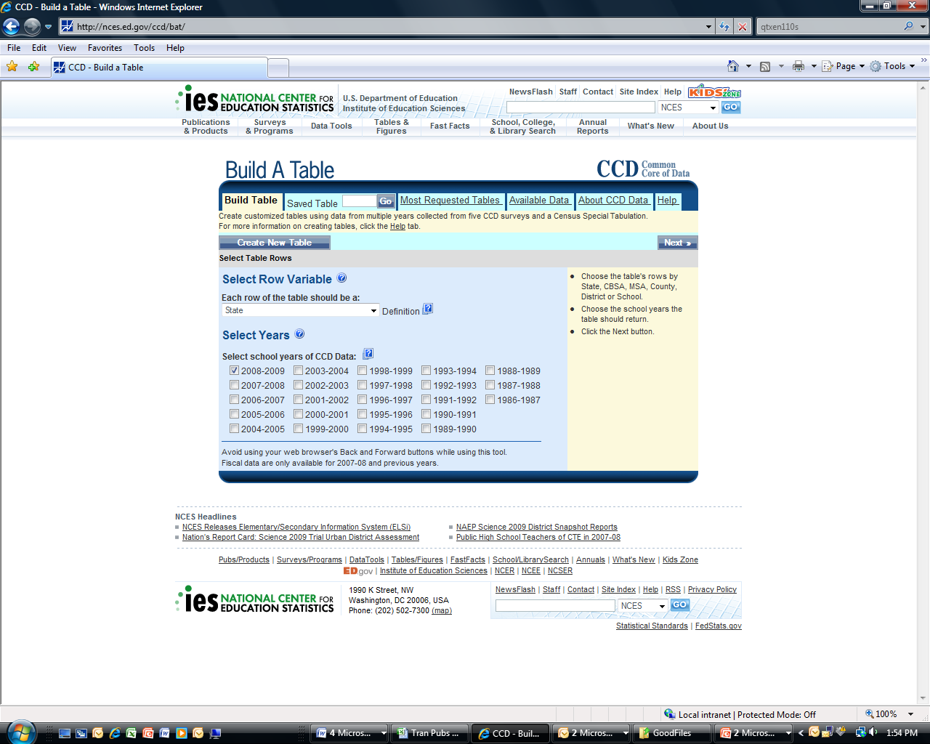

To BEGIN USING BAT, the user follows a series of steps (shown below):
(Step 1) Select a Row (represents the entity about which the user would want information)
- Row may be State, Statistical area, County, School District, or School
- Select year(s) for which information is wanted (one, selected years, or all years may be selected)
- Click Next
- Agree not to try to use CCD data to disclose the identity of individuals (Click OK)

Note--links to HELP, data sources, and variable definitions on BAT web pages
- The user will find a link to the “HELP” or Tutorial and data sources or “Available Data” at the top of each BAT page.
- The user will find definitions of all variables by putting the cursor over the on the left side of the variable name.
- The associated with “Select Columns,” “Select Filters,” and “Other Filters” provides the user a brief contextually relevant tutorial.

(Step 2) Select Data Items (Column Variables) shown on page below:

- Data items are grouped by category
- Scroll down and click on a category to see specific items
  - (No fiscal data for most recent year of non-fiscal data – most recent year of non-fiscal data is Fall data of the academic year)
  - (Variables available are appropriate to level selected in Step 1 – i.e., state, statistical area, school district, school level)
- Select an item by checking a box
- Scroll down for categories

Screen 2 – Column Variable Categories
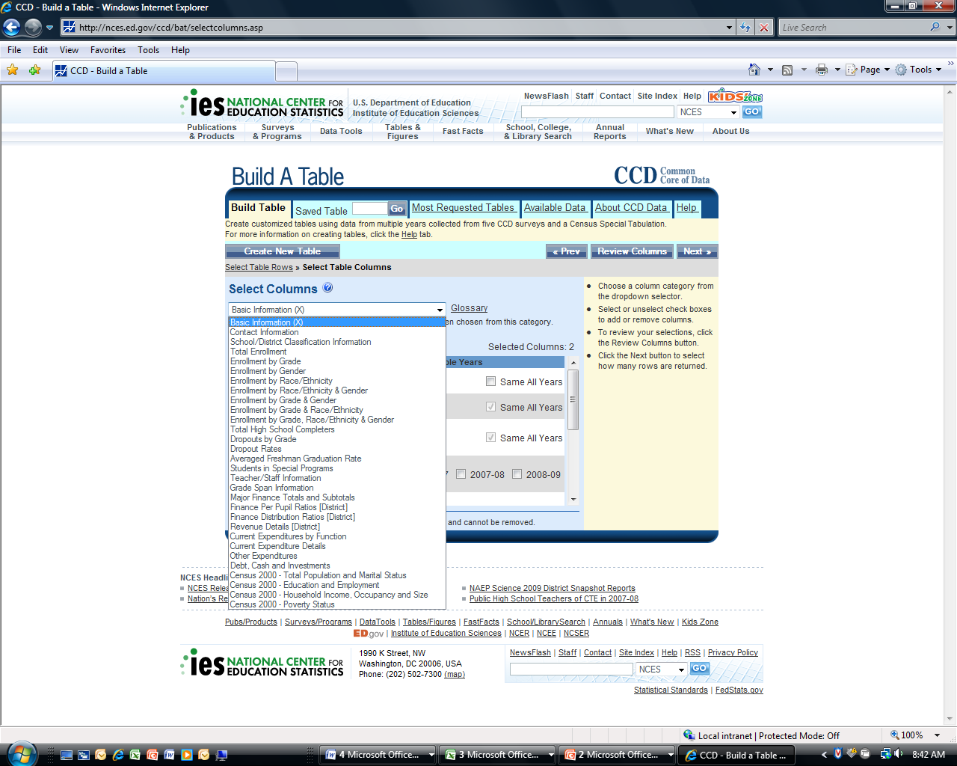

- Select more variables from other variable categories (maximum 50 columns) [NOTE: Variables that have been selected remain selected until the table has been produced.]
- e.g. Select Per-pupil ratios: [Shown in Screen Three (3) - below]
  - Total expenditures per student
  - Instruction expenditures per student

SCREEN 3—Selecting Variables (columns)

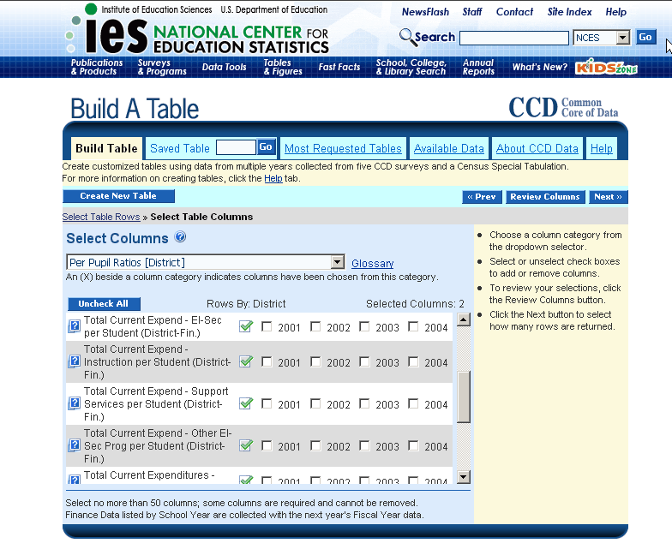

(Step 3) Filter variables and Refine selection

After all variables desired have been selected, click on next to continue to filter variables and customize the table. The following page shows a listing of states.

One state, selected states, or all states may be selected.

“Other Filters” shows variables that have been selected. These can be used to make additional table refinements (e.g., selecting specific school or district entities or selecting those with a range of enrollment or other attributes).

Screen 4 – Filtering Variables

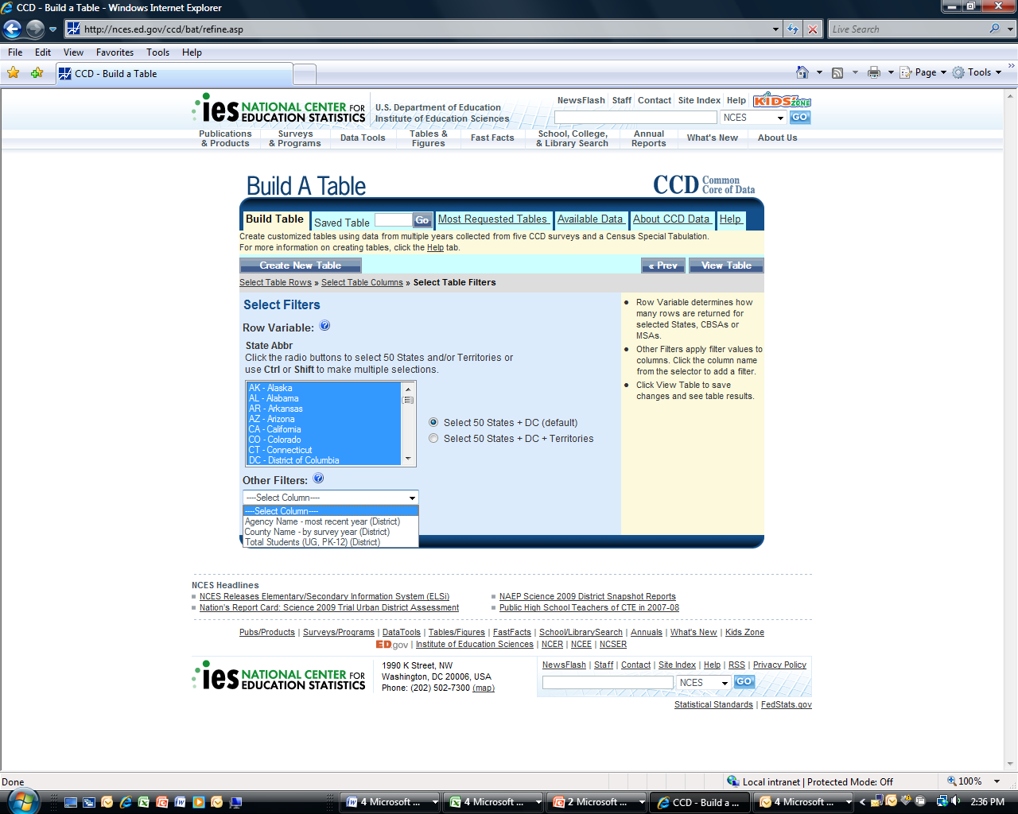

(Step 4) The user can request that the table be produced by clicking on “View Table.” The following is the table yield (Screen 5).

Screen 5 – BAT Table
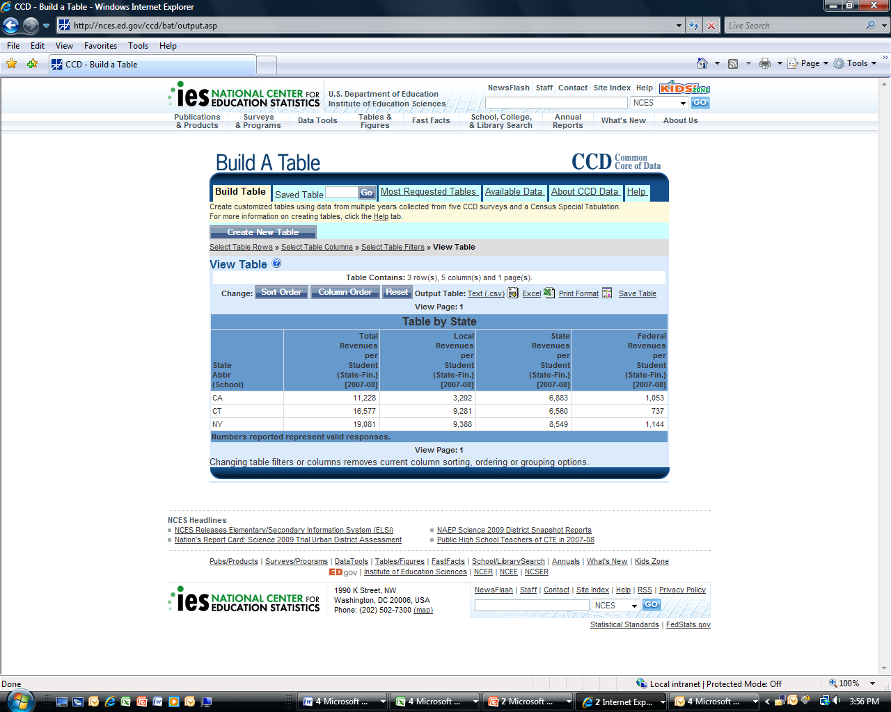
BAT Table output can be accessed via CSV or excel download, or viewed as a print file.

The table specifications that produced the table (which includes the variables selected and the filters that were applied) can also be saved and recalled in the future. Saving the tables yields a sequence number that can be entered to recall the table.
Summary

CCD Build-a-Table (BAT)

Performance Limits of BAT
- No more than 22,000 lines
- No more than 50 columns
- Some variables are missing for some states (not reported by SEA)
  - Tip: Run a test table by state before running lower-level analysis

Variable Selection
- Select from among hundreds of variables from 5 CCD (State fiscal and State non-fiscal, School District fiscal and School District non-fiscal, and school) data files covering a period from 1986 through 2008-09--23 years at present

Refine Data Selection (Using filters)
- Use filters to customize your table
- Select filters
  - State Abbreviation—e.g., CO for Colorado
  - Variables-any variables selected can be used to filter
    - Review other filters—e.g., Break out high schools, middle schools, big districts, little districts, rural vs. urban, boys vs. girls, and many other comparisons
    - Can also break out by categories for appropriate tables

Customize BAT Output
- Can sort (ascending) by selected columns
- Can move columns around
- Output to print, Excel, or generic comma separated variable format
- Can save table specifications for 30 days
- Can store the data tool address in favorites

Downloading and Saving Output
- Click View-a-Table
- Table you constructed will appear
- Download to Excel file (upper right hand corner), CSV file, or view table only as a print file
- After download
- Save as…..
- Save as Microsoft Excel Workbook
- e.g., Colorado expenditures per pupil
BAT data—public use school, school district fiscal and non-fiscal, and state level fiscal and non-fiscal universe data
- CCD data fully accessible to the public
- Data are presented in NCES publications and products, and in the press
- Public release files are free of cost
- Public release CCD data can be downloaded using BAT

