**PISA Mathematics Literacy Items (2006, 2012)**

The *Mathematics Literacy Items* document contains 11 mathematics assessment units and 24 items associated with these units. These released items from the PISA 2006 and 2012 assessments are distinct from the secure items, which are kept confidential so that they may be used in subsequent cycles to monitor trends. This set of PISA Mathematics Literacy Items is designed to be used in tandem with *PISA Mathematics Literacy Items and Scoring Guides (2006, 2012)*, which contains both the items and the PISA scoring guides adapted for classroom use.

**TABLE OF CONTENTS**

**UNIT NAME PAGE**

**Car drive 1**

**height 3**

**making a booklet 4**

**bicycles 6**

**seeing the tower 7**

**Charts 9**

**SAILING SHIPS 11**

**DRIP RATE 14**

**REVOLVING DOOR 16**

**APARTMENT PURCHASE 18**

**Sauce 19**

# Car drive

Kelly went for a drive in her car. During the drive, a cat ran in front of the car. Kelly slammed on the brakes and missed the cat.

Slightly shaken, Kelly decided to return home.

The graph below is a simplified record of the car’s speed during the drive.

9:00

9:04

9:08

9:12

Kelly’s drive

Time

72

60

48

36

24

12

0

Speed

(km/h)

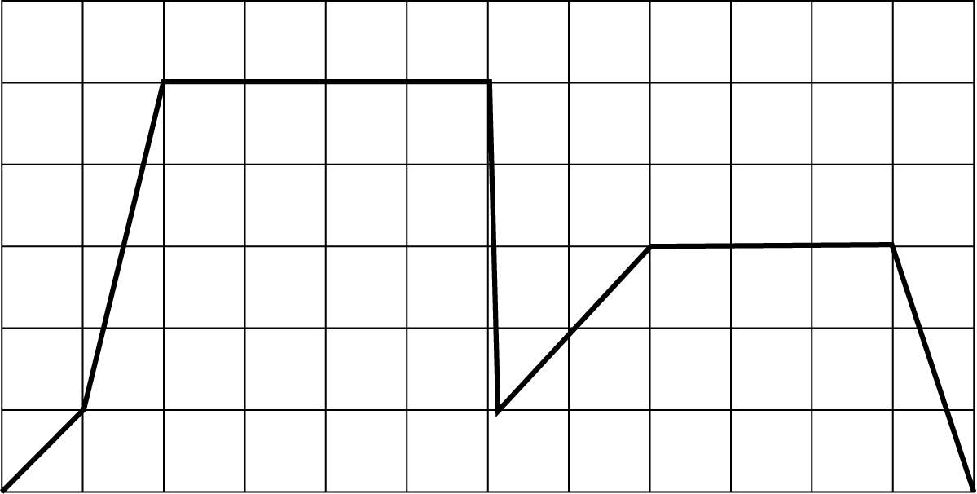

: CAR DRIVE M302Q01

What was the maximum speed of the car during the drive?

Maximum speed: km/h.

: CAR DRIVE M302Q02 - 019

What time was it when Kelly slammed on the brakes to avoid the cat?

Answer:

* 1. : CAR DRIVE M302Q03 - 019

Was the route Kelly took to return home shorter than the distance she had traveled from home to the place where the incident with the cat occurred? Give an explanation to support your answer, using information given in the graph.

# height

There are 25 girls in a class. The average height of the girls is 130 cm.

Question 1: HEIGHT M421Q01 - 019

Explain how the average height is calculated.

Question 2: HEIGHT M421Q02

Circle either “True” or “False” for each of the following statements.

|  |  |
| --- | --- |
| Statement | True or False |
| If there is a girl of height 132 cm in the class, there must be a girl of height 128 cm. | True */* False |
| The majority of the girls must have height 130 cm. | True */* False |
| If you rank all of the girls from the shortest to the tallest, then the middle one must have a height equal to  130 cm. | True */* False |
| Half of the girls in the class must be below 130 cm, and half of the girls must be above 130 cm. | True */* False |

Question 3: HEIGHT M421Q03

An error was found in one student’s height. It should have been 120 cm instead of 145 cm. What is the corrected average height of the girls in the class?

1. 126 cm
2. 127 cm
3. 128 cm
4. 129 cm
5. 144 cm

# making a booklet

Question 1: MAKING A BOOKLET M598Q01 - 019

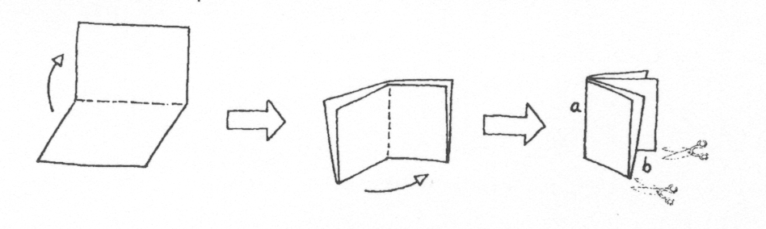*Figure 1*

Figure 1 shows how to make a small booklet. The instructions are given below:

* Take a piece of paper and fold it twice.
* Staple edge *a.*
* Cut open two edges at *b*.

The result is a small booklet with eight pages.

*Figure 2*

Figure 2 shows one side of a piece of paper that is used to make such a booklet. The page numbers have been put on the paper in advance.

The thick line indicates where the paper will be cut after folding.

Write the numbers 1, 4, 5 and 8 in the correct boxes in the following diagram to show which page number is directly behind each of the page numbers 2, 3, 6 and 7.

# bicycles

Justin, Samantha and Peter ride bicycles of different sizes. The following table shows the distance their bicycles travel for each complete turn of the wheels.

|  |  |  |  |  |  |  |
| --- | --- | --- | --- | --- | --- | --- |
|  | **Distance traveled in cm** | | | | | |
|  | 1 turn | 2 turns | 3 turns | 4 turns | 5 turns | 6 turns |
| Peter | 96 | 192 | 288 | 384 | 480 | … |
| Samantha | 160 | 320 | 480 | 640 | 800 | … |
| Justin | 190 | 380 | 570 | 760 | 950 | … |

Question 1: BICYCLES M810Q01

Peter pushed his bike for three complete turns of his wheel. If Justin did the same with his bike, how much further would Justin’s bike travel than Peter’s? Give your answer in centimeters.

Answer: cm.

Question 2: BICYCLES M810Q02

How many turns of the wheel does it take for Samantha’s bike to travel 1,280 cm?

Answer: turns.

Question 3: BICYCLES M810Q03 - 00 11 12 21 99

Peter’s bicycle has a wheel circumference of 96 cm (or 0.96 m). It is a three-speed bicycle with a low, a middle and a high gear. The gear ratios of Peter’s bicycle are:

Low 3:1 Middle 6:5 High 1:2

How many pedal turns would Peter take to travel 960 m in middle gear? Show your work.

**NOTE: A gear ratio of 3:1 means 3 complete pedal turns yields 1 complete wheel turn.**

# seeing the tower

Question 1: SEEING THE TOWER M833Q01

In Figures 1 and 2 below, you see two drawings of the **same** tower. In Figure 1 you see **three** faces of the roof of the tower. In Figure 2 you see **four** faces.

Figure 1

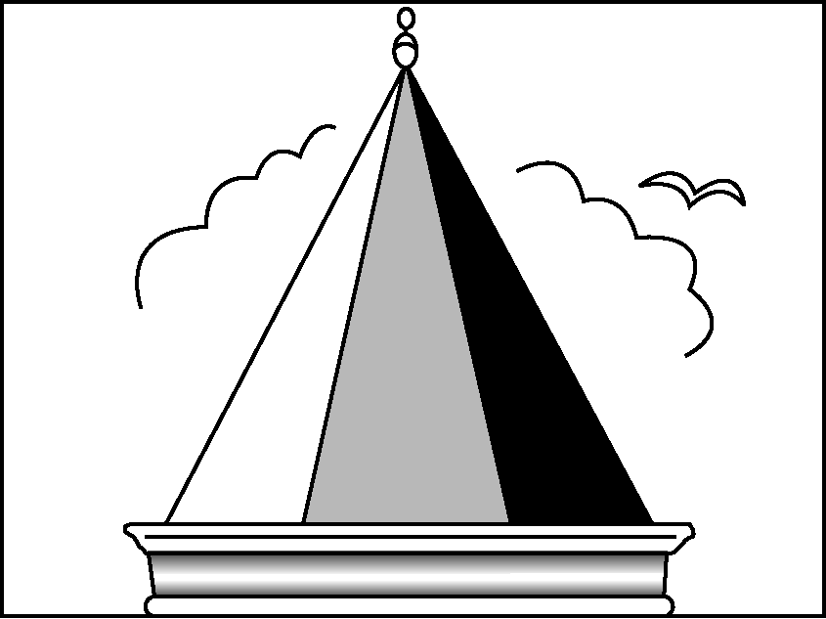

Figure 2

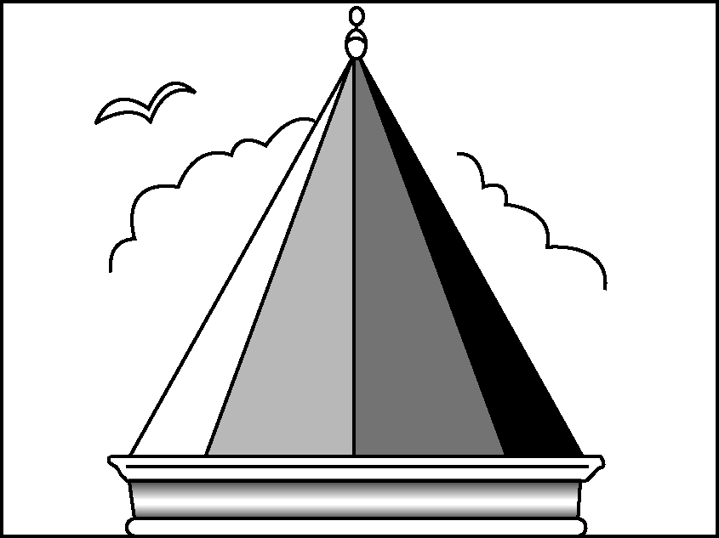

In the following diagram, the view of the roof of the tower, from above, is shown. Five positions are shown on the diagram. Each is marked with a cross () and they are labeled P1 – P5.

From each of these positions, a person viewing the tower would be able to see a number of faces of the roof of the tower.

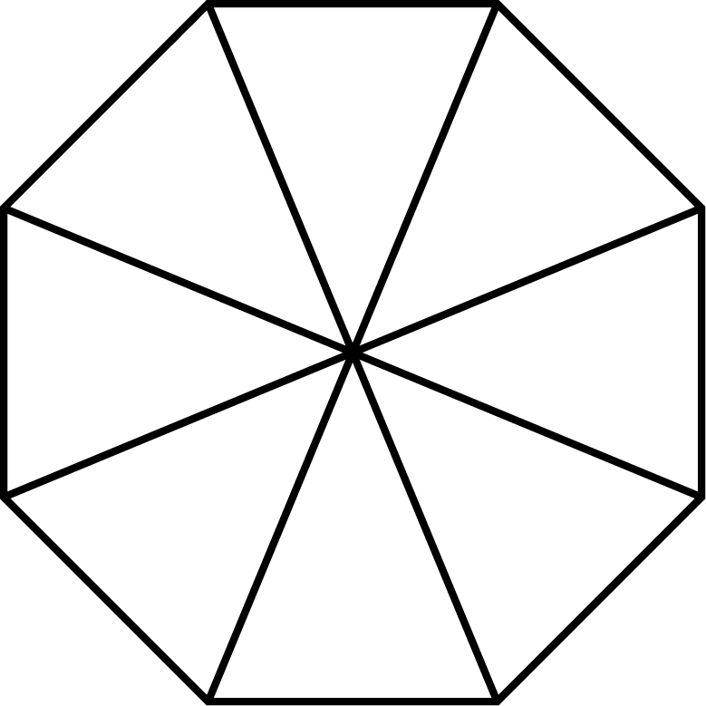

P1

P2

P4

P3

P5

In the table below, circle the number of faces that could be seen from each of these positions.

|  |  |
| --- | --- |
| **Position** | **Number of faces that could be seen from that position**  **(circle the correct number)** |
| P1 | 1 2 3 4 more than 4 |
| P2 | 1 2 3 4 more than 4 |
| P3 | 1 2 3 4 more than 4 |
| P4 | 1 2 3 4 more than 4 |
| P5 | 1 2 3 4 more than 4 |

Charts

In January, the new CDs of the bands *4U2Rock* and *The Kicking Kangaroos* were released. In February, the CDs of the bands *No One’s Darling* and *The Metalfolkies* followed. The following graph shows the sales of the bands’ CDs from January to June.

4U2Rock

Sales of CDs per month

0

250

750

2,000

2,250

1,750

1,500

1,000

1,250

500

Number of CDs sold per month

CD sales chart.eps

May

Jun

Apr

Mar

Jan

Feb

The Metalfolkies

No One’s Darling

The Kicking Kangaroos

Month

Question 1: CHARTS PM918Q01

How many CDs did the band *The Metalfolkies* sell in April?

1. 250
2. 500
3. 1,000
4. 1,270

Question 2: CHARTS PM918Q02

In which month did the band *No One’s Darling* sell more CDs than the band *The Kicking Kangaroos* for the first time?

1. No month
2. March
3. April
4. May

Question 5: CHARTS PM918Q05

The manager of *The Kicking Kangaroos* is worried because the number of their CDs that sold decreased from February to June.

What is the estimate of their sales volume for July if the same negative trend continues?

1. 70 CDs
2. 370 CDs
3. 670 CDs
4. 1,340 CDs

SAILING SHIPS

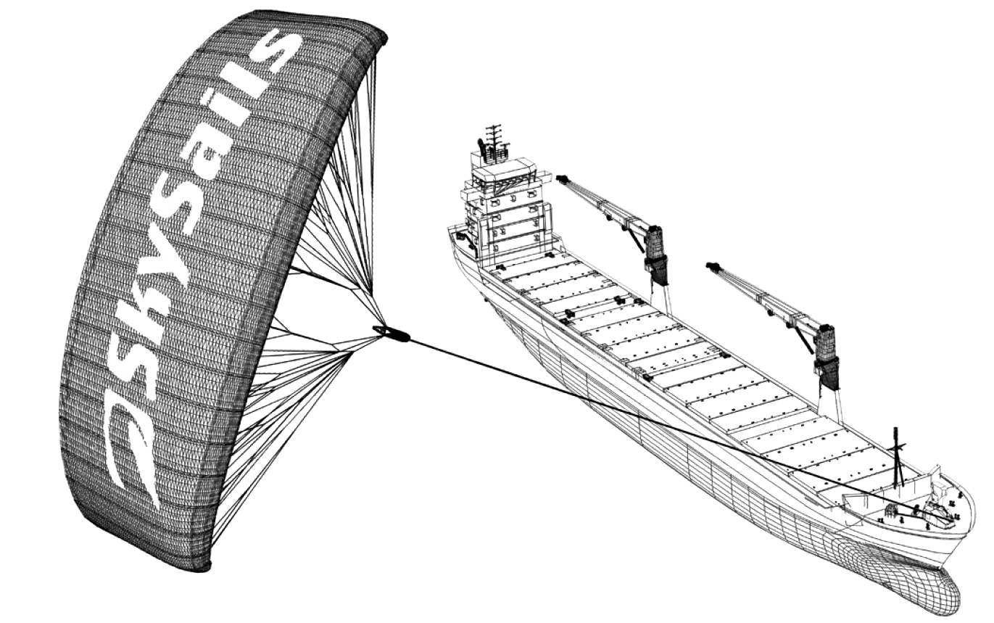Ninety-five percent of world trade is moved by sea, by roughly 50,000 tankers, bulk carriers and container ships. Most of these ships use diesel fuel.

© by skysails

Engineers are planning to develop wind power support for ships. Their proposal is to attach kite sails to ships and use the wind’s power to help reduce diesel consumption and the fuel’s impact on the environment.

Question 1: SAILING SHIPS PM923Q01

One advantage of using a kite sail is that it flies at a height of 150 m. There, the wind speed is approximately 25% higher than down on the deck of the ship.

At what approximate speed does the wind blow into a kite sail when a wind speed of 24 km/h is measured on the deck of the ship?

1. 6 km/h
2. 18 km/h
3. 25 km/h
4. 30 km/h
5. 49 km/h

Question 3: SAILING SHIPS PM923Q03

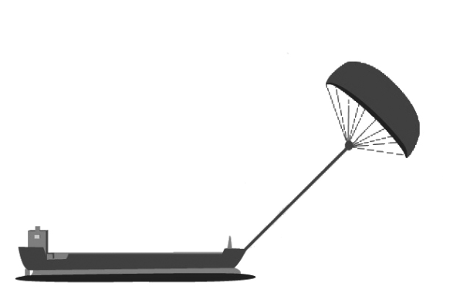Approximately what is the length of the rope for the kite sail, in order to pull the ship at an angle   
of 45° and be at a vertical height of 150 m, as shown in the   
diagram opposite?

1. 173 m
2. 212 m
3. 285 m

Note: Drawing not to scale.  
© by skysails

45º

90º

150 m

Rope

1. 300 m

Question 4: SAILING SHIPS PM923Q04 – 019

Due to high diesel fuel costs of 0.42 zeds per liter, the owners of the ship *NewWave* are thinking about equipping their ship with a kite sail.

It is estimated that a kite sail like this has the potential to reduce the diesel consumption by about 20% overall.

|  |  |
| --- | --- |
| Name: *NewWave* | ship.jpg |
| Type: freighter |
| Length: 117 meters |
| Breadth: 18 meters |
| Load capacity: 12,000 tons |
| Maximum speed: 19 knots |
| Diesel consumption per year without a kite sail: approximately 3,500,000 liters | |

The cost of equipping the *NewWave* with a kite sail is 2,500,000 zeds.

After about how many years would the diesel fuel savings cover the cost of the kite sail? Give calculations to support your answer.

Number of years:

DRIP RATE

Intravenous drips are used to deliver fluids and drugs to patients.

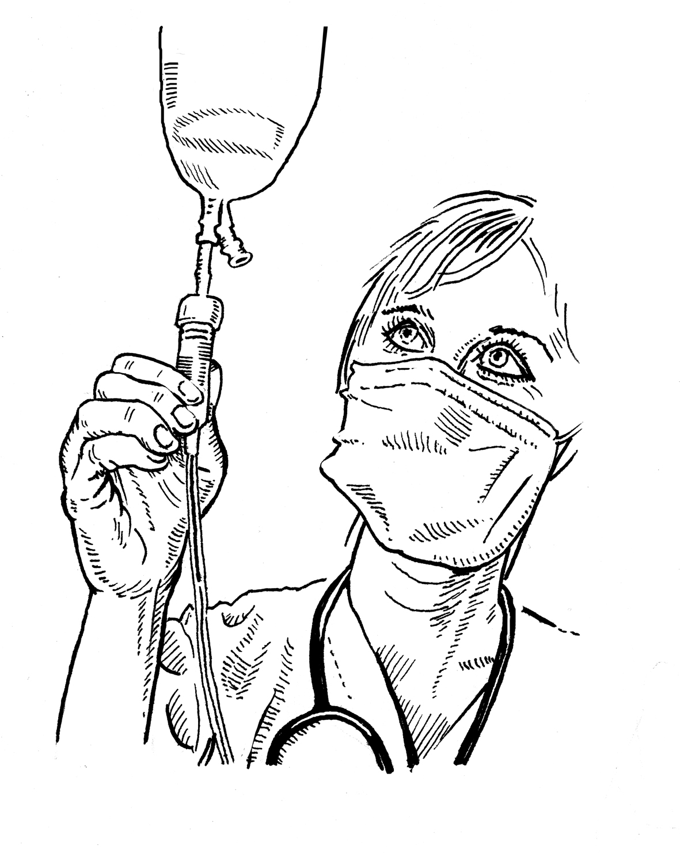

Nurses need to calculate the drip rate, *D*, in drops per minute for intravenous drips.

They use the formula $\text{D} \text{=}\frac{\text{dv}}{\text{60}\text{n}}$ where

*d* is the drop factor measured in drops per milliliter (mL)

*v* is the volume in mL of the intravenous drip

*n* is the number of hours the intravenous drip is required to run.

Question 1: DRIP RATE PM903Q01 – 0129

A nurse wants to double the time an intravenous drip runs for.

Describe precisely how *D* changes if *n* is **doubled** but *d* and *v* do not change.

Question 3: DRIP RATE PM903Q03 – 019

Nurses also need to calculate the volume of the intravenous drip, *v*, from the drip rate, *D*.

An intravenous drip with a drip rate of 50 drops per minute has to be given to a patient for 3 hours. For this intravenous drip the drop factor is 25 drops per milliliter.

What is the volume in mL of the intravenous drip?

Volume of the intravenous drip: mL

REVOLVING DOOR

A revolving door includes three wings which rotate within a circular space.   
The inside diameter of this space is 2 meters (200 centimeters). The three door wings divide the space into three equal sectors. The plan below shows the door wings in three different positions viewed from the top.

Exit

Entrance

200 cm

Wings

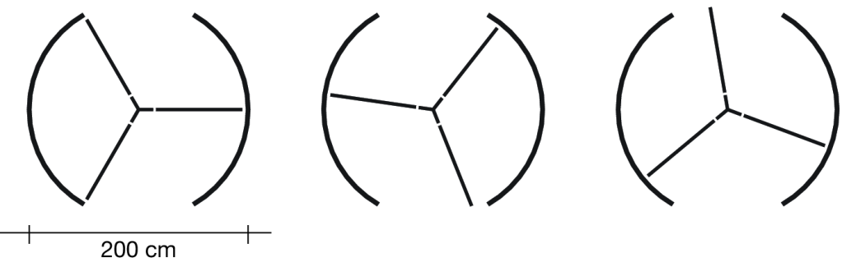

Question 1: REVOLVING DOOR PM995Q01 – 019

What is the size in degrees of the angle formed by two door wings?

Size of the angle: º

Question 2: REVOLVING DOOR PM995Q02 – 019

Possible air flow in this position.

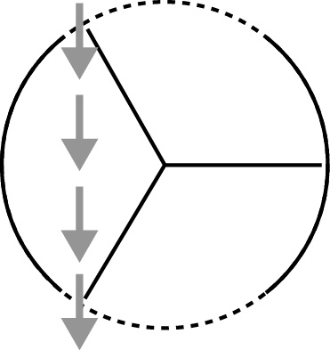The two door **openings** (the dotted arcs in the diagram) are the same size. If these openings are too wide the revolving wings cannot provide a sealed space and air could then flow freely between the entrance and the exit, causing unwanted heat loss or gain. This is shown in the diagram opposite.

What is the maximum arc length in centimeters (cm) that each door opening can have, so that air never flows freely between the entrance and the exit?

Maximum arc length: ................... cm

Question 3: REVOLVING DOOR PM995Q03

The door makes 4 complete rotations in a minute. There is room for a maximum of two people in each of the three door sectors.

What is the maximum number of people that can enter the building through the door in 30 minutes?

1. 60
2. 180
3. 240
4. 720

APARTMENT PURCHASE

This is the plan of the apartment that George’s parents want to purchase from a real estate agency.

apartment floor plan.eps

Scale:

1 cm represents 1 m

Kitchen

Bathroom

Living room

Terrace

Bedroom

Question 1: APARTMENT PURCHASE PM00FQ01 – 019

To estimate the total floor area of the apartment (including the terrace and the walls), you can measure the size of each room, calculate the area of each one and add all the areas together.

However, there is a more efficient method to estimate the total floor area where you only need to measure 4 lengths. Mark on the plan above the **four** lengths that are needed to estimate the total floor area of the apartment.

Sauce

Question 2: SAUCE PM924Q02 – 019

You are making your own dressing for a salad.

Here is a recipe for 100 milliliters (mL) of dressing.

|  |  |
| --- | --- |
| Salad oil: | 60 mL |
| Vinegar: | 30 mL |
| Soy sauce: | 10 mL |

How many milliliters (mL) of salad oil do you need to make 150 mL of this dressing?

Answer: ……………….. mL