Data Use Workshop: Self Assessment

PLAN

Mission and goals
In a sentence or two, describe the purpose of the SLDS your state is creating. That is, what are the intended outcomes in support of the agency’s or state’s policy or program goals?

Identification and prioritization of user roles
Name the top 2-3 user roles the SLDS is intended to serve (e.g., participating agency research staff, state policy makers, school administrators).

Identification of uses
For each of the above user roles, briefly describe the types of decisions and/or behaviors the SLDS is intended to inform.

Summary Assessment: my state is at the following stage for the PLAN component of our data use strategy
- We have just started to address the above questions
- We have a variety of responses to the above questions, but little consensus across the agency or state
- We have some consensus on responses to the above questions, but need to refine and communicate them
- We have strong consensus and clearly communicated responses to the above questions

CREATE

Stakeholder engagement
How will (or have) you identify(ied)/establish(ed) representative user groups?

What will be (or is) your process for convening, communicating with, gathering, and responding to the stakeholders’ feedback on the planned and executed resources created by the SLDS?

Products/Resources
What type(s) of products/resources will the SLDS generate? (e.g., dashboards, graphical reports, raw data extracts, etc.)

Delivery
By what means will you deliver data to your top priority user groups? (That is, how will you ensure that the data actually get into the hands of the intended users).

Summary Assessment: my state is at the following stage for the CREATE component of our data use strategy
- We do not yet have a plan for how we will engage stakeholders and deliver the SLDS resources to them
- We have a high-level plan for engaging stakeholders and delivering SLDS resources to them, but little detail regarding how it will work
- We have a detailed plan for engaging stakeholders and delivering SLDS resources to them, but we haven’t implemented it yet
- We are in the midst of implementing our stakeholder engagement and delivery plan

SUPPORT

User support
What supports will you provide to ensure users know how to access and use the system’s tools?

What supports will you provide to ensure users understand the data/analytics produced by the system?

Evolution and Sustainability
How will you obtain ongoing feedback from different user roles regarding desired enhancements and additions to the system’s outputs?

How will you capture and quantify the value the system brings to different user roles?

Summary Assessment: my state is at the following stage for the SUPPORT component of our data use strategy
- We do not have a user support or sustainability plan
- We are in the midst of creating a user support plan and will create a sustainability plan
- We have created a user support and sustainability plan but have not implemented them yet
- We are in the midst of implementing our user support and sustainability plan

Data Use Workshop: Action Plan

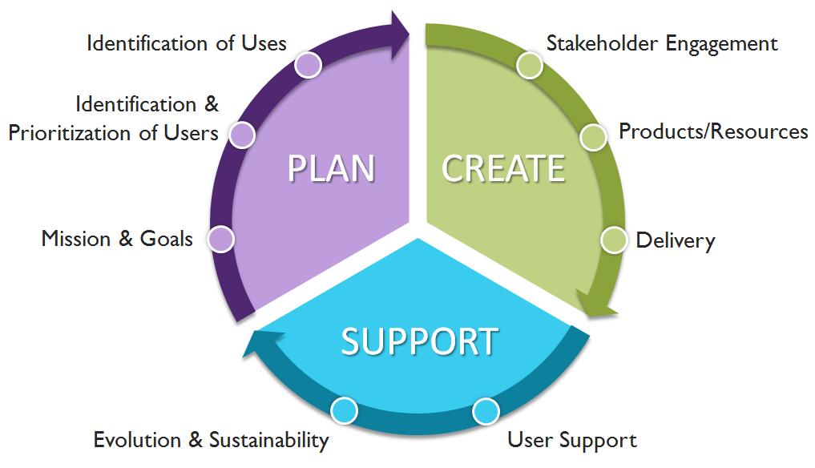
Action Plan Worksheet

Focus Area(s)
1.

2.

Action Step(s)

1.

2.

3.

Staff Involved

Timeframe for Completion

