**PISA Mathematics Literacy Items and Scoring Guides (2006, 2012)**

The *Mathematics Literacy Items and Scoring Guides* document contains 11 mathematics assessment units and 24 items associated with these units. These released items from the PISA 2006 and 2012 assessments are distinct from the secure items, which are kept confidential so that they may be used in subsequent cycles to monitor trends.

**TABLE OF CONTENTS**

**UNIT NAME PAGE**

**Car drive 1**

**height 4**

**making a booklet 7**

**bicycles 9**

**seeing the tower 12**

**Charts 14**

**SAILING SHIPS 18**

**DRIP RATE 22**

**REVOLVING DOOR 25**

**APARTMENT PURCHASE 28**

**Sauce 30**

# Car drive

Kelly went for a drive in her car. During the drive, a cat ran in front of the car. Kelly slammed on the brakes and missed the cat.

Slightly shaken, Kelly decided to return home.

The graph below is a simplified record of the car’s speed during the drive.

9:00

9:04

9:08

9:12

Kelly’s drive

Time

72

60

48

36

24

12

0

Speed

(km/h)

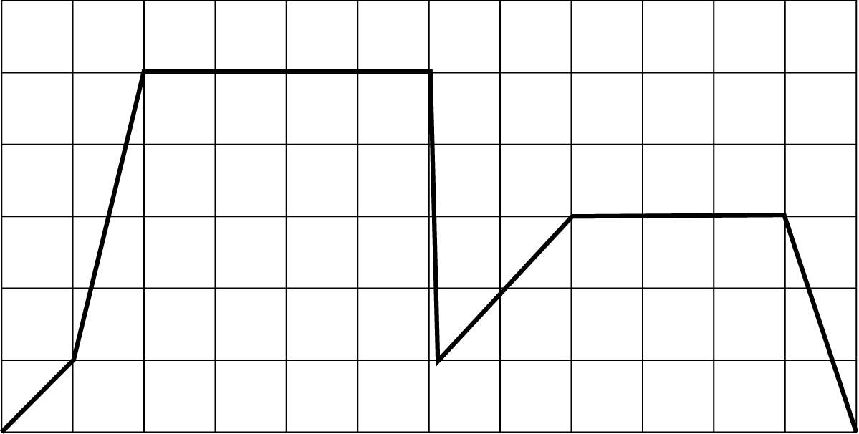

: CAR DRIVE M302Q01

*Question intent: Change and relationships*

What was the maximum speed of the car during the drive?

Maximum speed: km/h.

**SCORING**

***Correct***

60 km/h.

***Incorrect***

Other responses.

**Percentage of students answering correctly in PISA 2006:**

OECD average: **95%**

U.S.: **94**%

: CAR DRIVE M302Q02 - 019

*Question intent: Change and relationships*

What time was it when Kelly slammed on the brakes to avoid the cat?

Answer:

**SCORING**

***Correct***

9:06

OR

Six minutes past nine.

***Incorrect***

Other responses.

**Percentage of students answering**

**correctly in PISA 2006:**

OECD average: **81%**

U.S.: **82**%

* 1. : CAR DRIVE M302Q03 - 019

*Question intent: Change and relationships*

Was the route Kelly took to return home shorter than the distance she had traveled from home to the place where the incident with the cat occurred? Give an explanation to support your answer, using information given in the graph.

**SCORING**

***Correct***

Answer that the route home was shorter, with an adequate explanation.

Explanation refers to BOTH lower average speed AND (approximately) equal time on return journey, or equivalent argument. Note that an argument based on the lower area under the graph for the return journey would also be given Correct.

* The first part was longer than the trip home – it took the same amount of time but in the first part she was going much faster than the second part.
* The route Kelly took home was shorter because it took her less time and she was traveling slower.

***Incorrect***

Correct answer without adequate explanation.

* It was shorter because when she slammed on the brakes she had just gone over half time.
* The route home was shorter. It only covered 8 squares while the route there covered 9 squares.

OR

Other responses.

* No it was the same because it took her six minutes to get back but she drove slower.
* Looking at the graph if you include the time Kelly took to slow down for the cat it may have been a couple of seconds quicker but rounding off it was the same.
* You can tell by the graph that it was the same distance to where she stopped as the distance back home.

**Percentage of students answering correctly in PISA 2006:**

OECD average: **29%**

U.S.: **24%**

# height

There are 25 girls in a class. The average height of the girls is 130 cm.

Question 1: HEIGHT M421Q01 - 019

*Question intent: Uncertainty*

Explain how the average height is calculated.

**SCORING**

***Correct***

Explanations that include: Sum the individual heights and divide by 25.

* You add together every girl’s height and divide by the number of girls.
* Take all the girls’ heights, add them up, and divide by the amount of girls, in this case 25.
* The sum of all heights in the same unit divided by the number of girls.

***Incorrect***

Other responses.

**Percentage of students answering correctly in PISA 2006:**

OECD average: **63%**

U.S.: **60%**

Question 2: HEIGHT M421Q02

*Question intent: Uncertainty*

Circle either “True” or “False” for each of the following statements.

|  |  |
| --- | --- |
| Statement | True or False |
| If there is a girl of height 132 cm in the class, there must be a girl of height 128 cm. | True */* False |
| The majority of the girls must have height 130 cm. | True */* False |
| If you rank all of the girls from the shortest to the tallest, then the middle one must have a height equal to  130 cm. | True */* False |
| Half of the girls in the class must be below 130 cm, and half of the girls must be above 130 cm. | True */* False |

**SCORING**

***Correct***

False, False, False, False

***Incorrect***

Other responses.

**Percentage of students answering correctly in PISA 2006:**

OECD average: **16%**

U.S.: **16%**

Question 3: HEIGHT M421Q03

*Question intent: Uncertainty*

An error was found in one student’s height. It should have been 120 cm instead of 145 cm. What is the corrected average height of the girls in the class?

1. 126 cm
2. 127 cm
3. 128 cm
4. 129 cm
5. 144 cm

**SCORING**

***Correct***

D. 129 cm.

***Incorrect***

Other responses.

**Percentage of students answering correctly in PISA 2006:**

OECD average: **34%**

U.S.: **27%**

# making a booklet

Question 1: MAKING A BOOKLET M598Q01 - 019

*Question intent: Space and shape*

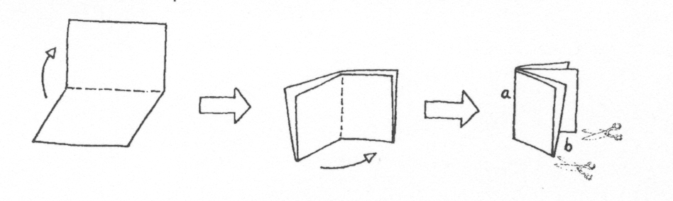*Figure 1*

Figure 1 shows how to make a small booklet. The instructions are given below:

* Take a piece of paper and fold it twice.
* Staple edge *a.*
* Cut open two edges at *b*.

The result is a small booklet with eight pages.

*Figure 2*

Figure 2 shows one side of a piece of paper that is used to make such a booklet. The page numbers have been put on the paper in advance.

The thick line indicates where the paper will be cut after folding.

Write the numbers 1, 4, 5 and 8 in the correct boxes in the following diagram to show which page number is directly behind each of the page numbers 2, 3, 6 and 7.

**SCORING**

***Correct***

Page numbers placed correctly in the following positions (ignore the orientation of the numbers):

***Incorrect***

1

8

5

4

Other responses.

**Percentage of students answering correctly in PISA 2006:**

OECD average: **60%**

U.S.: **60%**

# bicycles

Justin, Samantha and Peter ride bicycles of different sizes. The following table shows the distance their bicycles travel for each complete turn of the wheels.

|  |  |  |  |  |  |  |
| --- | --- | --- | --- | --- | --- | --- |
|  | **Distance traveled in cm** | | | | | |
|  | 1 turn | 2 turns | 3 turns | 4 turns | 5 turns | 6 turns |
| Peter | 96 | 192 | 288 | 384 | 480 | … |
| Samantha | 160 | 320 | 480 | 640 | 800 | … |
| Justin | 190 | 380 | 570 | 760 | 950 | … |

Question 1: BICYCLES M810Q01

*Question intent: Quantity*

Peter pushed his bike for three complete turns of his wheel. If Justin did the same with his bike, how much further would Justin’s bike travel than Peter’s? Give your answer in centimeters.

Answer: cm.

**SCORING**

***Correct***

282 cm.

***Incorrect***

Other responses.

**Percentage of students answering correctly in PISA 2006:**

OECD average: **62%**

U.S.: **60%**

Question 2: BICYCLES M810Q02

*Question intent: Quantity*

How many turns of the wheel does it take for Samantha’s bike to travel 1,280 cm?

Answer: turns.

**SCORING**

***Correct***

8.

***Incorrect***

Other responses.

**Percentage of students answering correctly in PISA 2006:**

OECD average: **69%**

U.S.: **62%**

Question 3: BICYCLES M810Q03 - 00 11 12 21 99

*Question intent: Change and relationships*

Peter’s bicycle has a wheel circumference of 96 cm (or 0.96 m). It is a three-speed bicycle with a low, a middle and a high gear. The gear ratios of Peter’s bicycle are:

Low 3:1 Middle 6:5 High 1:2

How many pedal turns would Peter take to travel 960 m in middle gear? Show your work.

**NOTE: A gear ratio of 3:1 means 3 complete pedal turns yields 1 complete wheel turn.**

**SCORING**

***Fully Correct***

1,200 pedal turns, with a fully correct method. Note that the correct answer, even when no work is shown, implies a fully correct method, and should be given full credit.

* + 960 m requires 1,000 wheel turns, which corresponds to1,000 × 6/5 =1,200 pedal turns

***Partially Correct***

12 pedal turns, calculated by a correct method but without the correct conversion of units.

* + 960 m requires 10 wheel turns (student forgot that distance in the table is given in cm), which corresponds to 10 × 6/5 =12 pedal turns

Correct method but with other slight computational error or incomplete calculation.

* + 3 pedal turns give 2.5 wheel turns, and 1 wheel turn = 0.96 meters, so 3 pedal turns = 2.4 meters. Therefore 960 m takes 400 pedal turns.
  + 1,000 wheel turns are needed (960/0.96) to travel 960 m, so 833 pedal turns are required in middle gear (5/6 of 1000). *[The method is correct, but the ratio has been inverted.]*
  + 5 x 0.96 = 4.8, and 960/4.8 = 200. So 200 turns. Now 200/5 = 40 and 40 x 6 = 240. So, 240 pedal turns are required [*A single error, the redundant first multiplication by 5, but an otherwise correct method.]*

***Incorrect***

Other responses.

* + 96,000/5 = 19,200, and 19,200 × 6 = 115,200 pedal turns. *[The wheel circumference has not been taken into account.]*

**Percentage of students answering correctly in PISA 2006:**

OECD average: **19%**

U.S.: **12%**

# seeing the tower

Question 1: SEEING THE TOWER M833Q01

*Question intent: Space and shape*

In Figures 1 and 2 below, you see two drawings of the **same** tower. In Figure 1 you see **three** faces of the roof of the tower. In Figure 2 you see **four** faces.

Figure 1

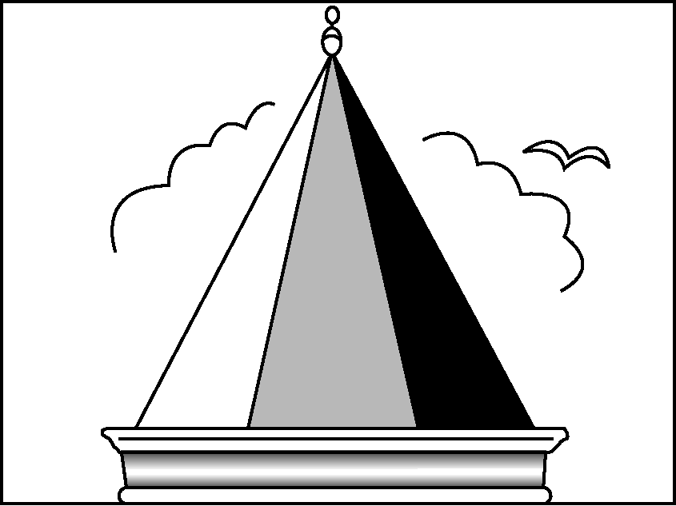

Figure 2

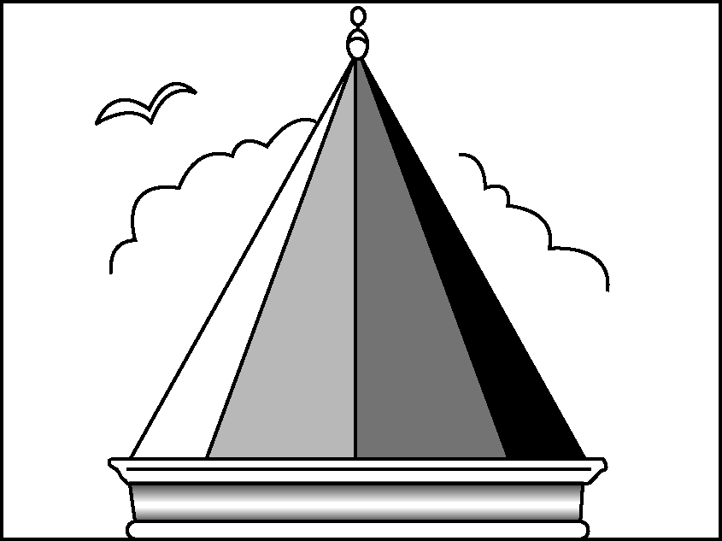

In the following diagram, the view of the roof of the tower, from above, is shown. Five positions are shown on the diagram. Each is marked with a cross () and they are labeled P1 – P5.

From each of these positions, a person viewing the tower would be able to see a number of faces of the roof of the tower.

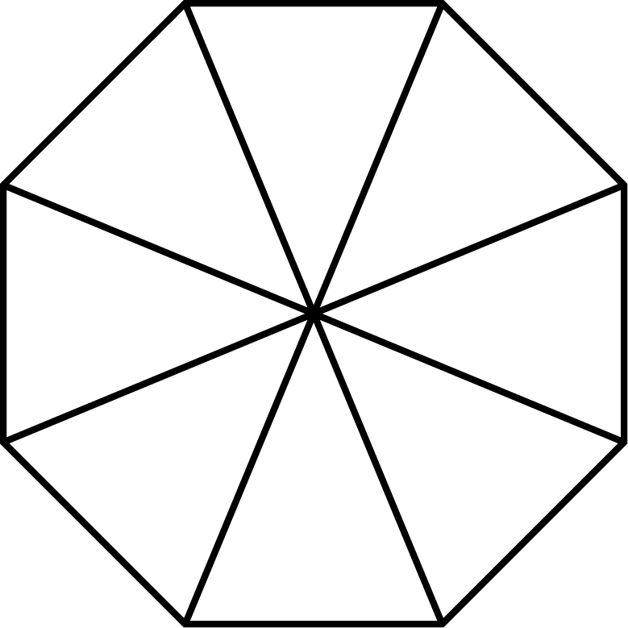

P1

P2

P4

P3

P5

In the table below, circle the number of faces that could be seen from each of these positions.

|  |  |
| --- | --- |
| **Position** | **Number of faces that could be seen from that position**  **(circle the correct number)** |
| P1 | 1 2 3 4 more than 4 |
| P2 | 1 2 3 4 more than 4 |
| P3 | 1 2 3 4 more than 4 |
| P4 | 1 2 3 4 more than 4 |
| P5 | 1 2 3 4 more than 4 |

**SCORING**

***Correct***

The following responses are circled for points P1-P5 respectively: 4, 3, 1, 2, 2

***Incorrect***

Other responses.

**Percentage of students answering correctly in PISA 2006:**

OECD average: **30%**

U.S.: **24%**

Charts

In January, the new CDs of the bands *4U2Rock* and *The Kicking Kangaroos* were released. In February, the CDs of the bands *No One’s Darling* and *The Metalfolkies* followed. The following graph shows the sales of the bands’ CDs from January to June.

4U2Rock

Sales of CDs per month

0

250

750

2,000

2,250

1,750

1,500

1,000

1,250

500

Number of CDs sold per month

CD sales chart.eps

May

Jun

Apr

Mar

Jan

Feb

The Metalfolkies

No One’s Darling

The Kicking Kangaroos

Month

Question 1: CHARTS PM918Q01

*Question intent: Uncertainty and data*

How many CDs did the band *The Metalfolkies* sell in April?

1. 250
2. 500
3. 1,000
4. 1,270

**SCORING**

***Correct***

B. 500

***Incorrect***

Other responses.

**Percentage of students answering**

**correctly in PISA 2012:**

OECD average: **87%**

U.S.: **92%**

Question 2: CHARTS PM918Q02

*Question intent: Uncertainty and data*

In which month did the band *No One’s Darling* sell more CDs than the band *The Kicking Kangaroos* for the first time?

1. No month
2. March
3. April
4. May

**SCORING**

***Correct***

C. April

***Incorrect***

Other responses

**Percentage of students answering correctly in PISA 2012:**

OECD average:  **80%**

U.S.: **77%**

Question 5: CHARTS PM918Q05

*Question intent: Uncertainty and data*

The manager of *The Kicking Kangaroos* is worried because the number of their CDs that sold decreased from February to June.

What is the estimate of their sales volume for July if the same negative trend continues?

1. 70 CDs
2. 370 CDs
3. 670 CDs
4. 1,340 CDs

**SCORING**

***Correct***

B. 370 CDs

***Incorrect***

Other responses.

**Percentage of students answering correctly in PISA 2012:**

OECD average: **77%**

U.S.: **77%**

SAILING SHIPS

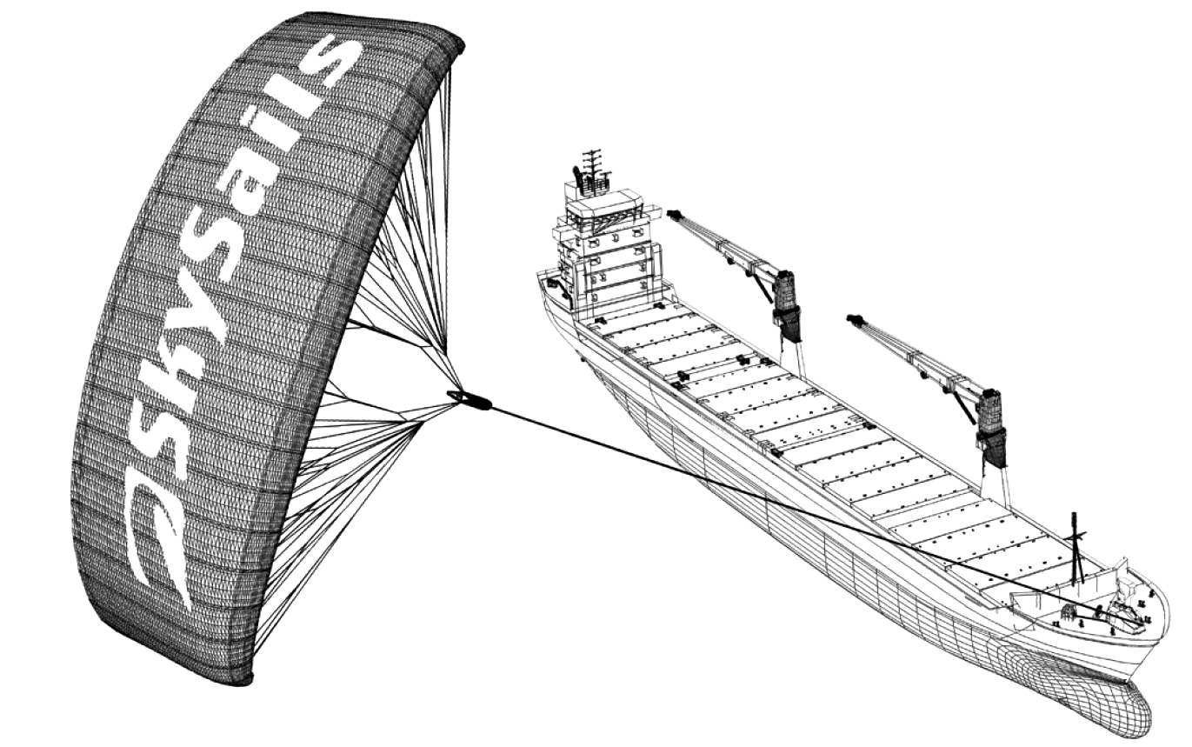Ninety-five percent of world trade is moved by sea, by roughly 50,000 tankers, bulk carriers and container ships. Most of these ships use diesel fuel.

© by skysails

Engineers are planning to develop wind power support for ships. Their proposal is to attach kite sails to ships and use the wind’s power to help reduce diesel consumption and the fuel’s impact on the environment.

Question 1: SAILING SHIPS PM923Q01

*Question intent: Quantity*

One advantage of using a kite sail is that it flies at a height of 150 m. There, the wind speed is approximately 25% higher than down on the deck of the ship.

At what approximate speed does the wind blow into a kite sail when a wind speed of 24 km/h is measured on the deck of the ship?

1. 6 km/h
2. 18 km/h
3. 25 km/h
4. 30 km/h
5. 49 km/h

**SCORING**

***Correct***

D. 30 km/h

***Incorrect***

Other responses.

**Percentage of students answering correctly in PISA 2012:**

OECD average: **60%**

U.S.: **50%**

Question 3: SAILING SHIPS PM923Q03

*Question intent: Space and shape*

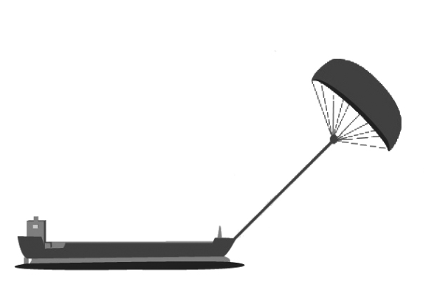Approximately what is the length of the rope for the kite sail, in order to pull the ship at an angle   
of 45° and be at a vertical height of 150 m, as shown in the   
diagram opposite?

1. 173 m
2. 212 m
3. 285 m

Note: Drawing not to scale.  
© by skysails

45º

90º

150 m

Rope

1. 300 m

**SCORING**

***Correct***

B. 212 m

***Incorrect***

Other responses.

**Percentage of students answering correctly in PISA 2012:**

OECD average: **50%**

U.S.: **44%**

Question 4: SAILING SHIPS PM923Q04 – 019

*Question intent:* Change and relationships

Due to high diesel fuel costs of 0.42 zeds per liter, the owners of the ship *NewWave* are thinking about equipping their ship with a kite sail.

It is estimated that a kite sail like this has the potential to reduce the diesel consumption by about 20% overall.

|  |  |
| --- | --- |
| Name: *NewWave* | ship.jpg |
| Type: freighter |
| Length: 117 meters |
| Breadth: 18 meters |
| Load capacity: 12,000 tons |
| Maximum speed: 19 knots |
| Diesel consumption per year without a kite sail: approximately 3,500,000 liters | |

The cost of equipping the *NewWave* with a kite sail is 2,500,000 zeds.

After about how many years would the diesel fuel savings cover the cost of the kite sail? Give calculations to support your answer.

Number of years:

**SCORING**

***Correct***

A solution from 8 to 9 years is provided with adequate (mathematical) calculations.

• Diesel consumption per year without a sail: 3.5 million liters, price 0.42 zed/liter, costs for diesel without a sail 1,470,000 zeds. If 20% is saved with the sail this results in a saving of 1,470,000 x 0.2 = 294,000 zeds per year. Thus: 2,500,000 /

294,000 ≈ 8.5, i.e.: After about 8 to 9 years, the sail becomes (financially)

worthwhile.

***Incorrect***

Other responses.

**Percentage of students answering correctly in PISA 2012:**

OECD average: **15%**

U.S.: **12%**

DRIP RATE

Intravenous drips are used to deliver fluids and drugs to patients.

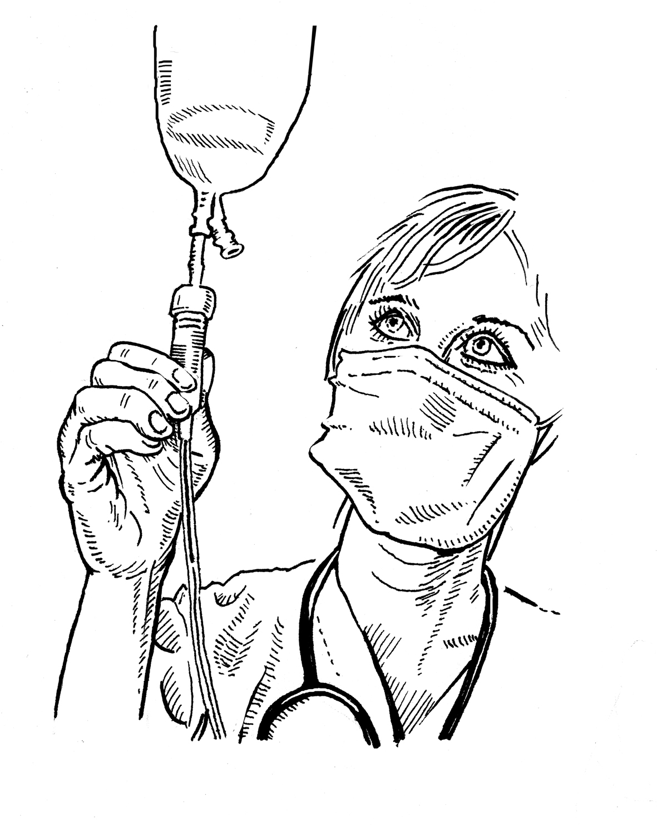

Nurses need to calculate the drip rate, *D*, in drops per minute for intravenous drips.

They use the formula $\text{D} \text{=}\frac{\text{dv}}{\text{60}\text{n}}$ where

*d* is the drop factor measured in drops per milliliter (mL)

*v* is the volume in mL of the intravenous drip

*n* is the number of hours the intravenous drip is required to run.

Question 1: DRIP RATE PM903Q01 – 0129

*Question intent: Change and relationships*

A nurse wants to double the time an intravenous drip runs for.

Describe precisely how *D* changes if *n* is **doubled** but *d* and *v* do not change.

SCORING

Fully Correct

Explanation describes both the direction of the effect and its size.

* It halves
* It is half
* D will be 50% smaller
* D will be half as big

Partially Correct

A response which correctly states EITHER the direction OR the size of the effect, but not BOTH.

* D gets smaller *[no size]*
* There’s a 50% change *[no direction]*
* D gets bigger by 50%. *[incorrect direction but correct size]*

Incorrect

Other responses.

* D will also double *[Both the size and direction are incorrect.]*

**Percentage of students answering correctly in PISA 2012:**

OECD average: **22%**

U.S.: **19%**

Question 3: DRIP RATE PM903Q03 – 019

*Question intent: Change and relationships*

Nurses also need to calculate the volume of the intravenous drip, *v*, from the drip rate, *D*.

An intravenous drip with a drip rate of 50 drops per minute has to be given to a patient for 3 hours. For this intravenous drip the drop factor is 25 drops per milliliter.

What is the volume in mL of the intravenous drip?

Volume of the intravenous drip: mL

SCORING

Correct

360 or a correctly transposed and substituted solution.

* 360
* (60 × 3 × 50) ÷ 25 *[Correct transposition and substitution.]*

Incorrect

Other responses.

**Percentage of students answering correctly in PISA 2012:**

OECD average**: 26%**

U.S.:  **30%**

REVOLVING DOOR

A revolving door includes three wings which rotate within a circular space.   
The inside diameter of this space is 2 meters (200 centimeters). The three door wings divide the space into three equal sectors. The plan below shows the door wings in three different positions viewed from the top.

Exit

Entrance

200 cm

Wings

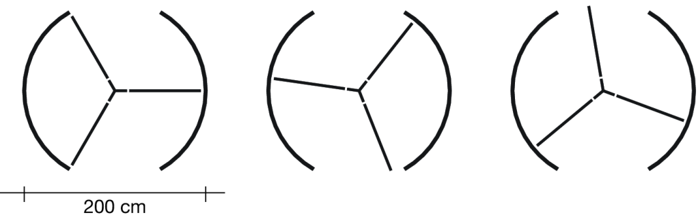

Question 1: REVOLVING DOOR PM995Q01 – 019

*Question intent: Space and shape*

What is the size in degrees of the angle formed by two door wings?

Size of the angle: º

SCORING

Correct

120 *[accept the equivalent reflex angle: 240]*.

Incorrect

Other responses.

**Percentage of students answering correctly in PISA 2012:**

OECD average: **58%**

U.S.: **47%**

Question 2: REVOLVING DOOR PM995Q02 – 019

*Question intent: Space and shape*

Possible air flow in this position.

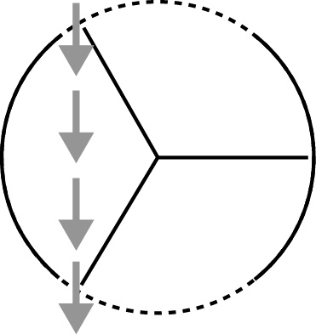The two door **openings** (the dotted arcs in the diagram) are the same size. If these openings are too wide the revolving wings cannot provide a sealed space and air could then flow freely between the entrance and the exit, causing unwanted heat loss or gain. This is shown in the diagram opposite.

What is the maximum arc length in centimeters (cm) that each door opening can have, so that air never flows freely between the entrance and the exit?

Maximum arc length: ................... cm

SCORING

Correct

Answers in the range from 103 to 105. *[Accept answers* *calculated as 1/6th of the circumference ($\frac{\text{100}\text{π}}{\text{3}})$. Also accept an answer of 100 only if it is clear that this response resulted from using π = 3. Note: Answer of 100 without supporting work could be obtained by a simple guess that it is the same as the radius (length of a single wing).]*

Incorrect

Other responses.

* 209 *[states the total size of the openings rather than the size of “each” opening].*

**Percentage of students answering correctly in PISA 2012:**

OECD average: **4%**

U.S.: **2%**

Question 3: REVOLVING DOOR PM995Q03

*Question intent:* *Quantity*

The door makes 4 complete rotations in a minute. There is room for a maximum of two people in each of the three door sectors.

What is the maximum number of people that can enter the building through the door in 30 minutes?

1. 60
2. 180
3. 240
4. 720

**SCORING**

***Correct***

D. 720

***Incorrect***

Other responses.

**Percentage of students answering correctly in PISA 2012:**

OECD average: **46%**

U.S.: **45%**

APARTMENT PURCHASE

This is the plan of the apartment that George’s parents want to purchase from a real estate agency.

apartment floor plan.eps

Scale:

1 cm represents 1 m

Kitchen

Bathroom

Living room

Terrace

Bedroom

Question 1: APARTMENT PURCHASE PM00FQ01 – 019

*Question intent: Space and shape*

To estimate the total floor area of the apartment (including the terrace and the walls), you can measure the size of each room, calculate the area of each one and add all the areas together.

However, there is a more efficient method to estimate the total floor area where you only need to measure 4 lengths. Mark on the plan above the **four** lengths that are needed to estimate the total floor area of the apartment.

SCORING

Correct

Has indicated the four dimensions needed to estimate the floor area of the apartment on the plan. There are 9 possible solutions as shown in the diagrams below.

* A = (9.7m x 8.8m) – (2m x 4.4m), A = 76.56m2 *[Clearly used only 4 lengths to measure and calculate required area.]*

Incorrect

Other responses.

**Percentage of students answering correctly in PISA 2012:**

OECD average**: 45%**

U.S.: **38**%

Sauce

Question 2: SAUCE PM924Q02 – 019

*Question intent: Quantity*

You are making your own dressing for a salad.

Here is a recipe for 100 milliliters (mL) of dressing.

|  |  |
| --- | --- |
| Salad oil: | 60 mL |
| Vinegar: | 30 mL |
| Soy sauce: | 10 mL |

How many milliliters (mL) of salad oil do you need to make 150 mL of this dressing?

Answer: ……………….. mL

**SCORING**

***Correct***

90

• 60 + 30

***Incorrect***

Other responses.

* 1.5 times more

**Percentage of students answering correctly in PISA 2012:**

OECD average: **64%**

U.S.: **51**%