PISA Financial Literacy Sample Items and Scoring Guides
The Financial Literacy Sample Items and Scoring Guides document contains 9 sample units and 10 items associated with these units. These are sample items from the PISA 2012 assessment. They are distinct from the secure items, which are kept confidential so that they may be used in subsequent cycles to monitor trends.

TABLE OF CONTENTS
UNIT NAME PAGE
spending choices 3
travel money 5
new offer 7
at the market 9
pay sTUB 12
bank error 14
new DEBIT card 16
shares 18
motorCYCLE insurance 20

spending choices

Claire and her friends are renting a house.
They have all been working for two months.
They do not have any savings.
They are paid monthly and have just received their pay checks.
They have made this “To do” list.

To do

- Get cable TV
- Pay the rent
- Buy outdoor furniture

Question 1: SPENDING CHOICES PF056Q01

Which of the tasks on the list are likely to need prompt attention from Claire and her friends?
Circle “Yes” or “No” for each task.

Task | Is the task likely to need prompt attention?
Get cable TV. | Yes / No
Pay the rent. | Yes / No
Buy outdoor furniture. | Yes / No

SCORING

Question intent: Recognize which item should be prioritized when working within a budget

Full Credit

Three correct responses: No, Yes, No, in that order.

No Credit

Fewer than three correct responses.

travel money

Natasha works in a restaurant 3 evenings each week.

She works for 4 hours each evening and she earns 10 zeds per hour.

Natasha also earns 80 zeds each week in tips.

Natasha saves exactly half of the total amount of money she earns each week.

Question 1: TRAVEL MONEY PF026Q01

Natasha wants to save 600 zeds for a vacation.

How many weeks will it take Natasha to save 600 zeds?

Number of weeks: .................................

SCORING

Question intent: Calculate the time needed to accumulate savings

Full Credit

6

No Credit

Other responses.

new offer

Mrs. Jones has a loan of 8,000 zeds with FirstZed Finance. The annual interest rate on the loan is 15%. Her repayments each month are 150 zeds.

After one year, Mrs. Jones still owes 7,400 zeds.

Another finance company called Zedbest will give Mrs. Jones a loan of 10,000 zeds with an annual interest rate of 13%. Her repayments each month would also be 150 zeds.

Question 1: NEW OFFER PF025Q02

What is one possible negative financial consequence for Mrs. Jones if she agrees to the Zedbest loan?

...............................................................................................................................
...............................................................................................................................
...............................................................................................................................

SCORING

Question intent: Recognize a negative consequence of having a large loan

Full Credit

Refers to Mrs. Jones having more debt.

Refers to paying more interest in total.

Refers to taking longer to pay the loan off.

Refers to the possibility of paying a cancellation fee with First Zed.

No Credit

Other responses.

at the market

You can buy tomatoes by the pound or by the box.
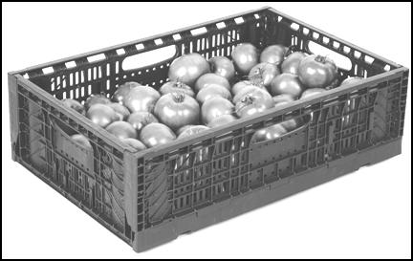

2.75 zeds per lb 22 zeds for a 10 lb box

Question 1: at the market PF011Q02

The box of tomatoes is better value for the money than the loose tomatoes.

Give a reason to support this statement.

.......................................................................................................................

.......................................................................................................................

........................................................................................................................

SCORING

Question intent: Recognize value by comparing prices per unit

Full Credit

Explicitly or implicitly recognizes that price per pound of boxed tomatoes is less than the price per pound for loose tomatoes.

No Credit

Other responses.

Question 2: at the market PF011Q03

Buying a box of tomatoes may be a bad financial decision for some people.

Explain why.

...............................................................................................................................

...............................................................................................................................

...............................................................................................................................

SCORING

Question intent: Recognize that buying in bulk can be wasteful

Full Credit

Refers to wastage if a larger amount of tomatoes is not needed.

Refers to the idea that some people cannot afford the higher absolute cost of buying in bulk.

No Credit

Other responses.

pay STUB

Each month, Jane’s salary is paid into her bank account.

This is Jane’s pay stub for July.

EMPLOYEE PAY STUB: Jane Green
Position: Manager | July 1 to July 31
Gross salary | 2,800 zeds
Deductions | 300 zeds
Net salary | 2,500 zeds
Gross salary to date this year | 19,600 zeds

Question 1: PAY STUB PF067Q01

How much money did Jane’s employer pay into her bank account on July 31?

A 300 zeds
B 2,500 zeds
C 2,800 zeds
D 19,600 zeds

SCORING

Question intent: Identify the net salary on a pay stub

Full Credit

B. 2,500 zeds

No Credit

Other responses.

bank error

David banks with ZedBank. He receives this e-mail message.

Dear ZedBank member,

There has been an error on the ZedBank server, and your Internet login details have been lost.

As a result, you have no access to Internet banking.

Most importantly, your account is no longer secure.

Please click on the link below and follow the instructions to restore access. You will be asked to provide your Internet banking details.

https://ZedBank.com/

Question 1: bank error PF053Q01

Which of these statements would be good advice for David?

Circle “Yes” or “No” for each statement.
Statement | Is this statement good advice for David?
Reply to the e-mail message and provide his Internet banking details. | Yes / No
Reply to the e-mail message and ask for more information. | Yes / No
Contact his bank to inquire about the e-mail message. | Yes / No
If the link is the same as his bank’s website address, click on the link and follow the instructions. | Yes / No

SCORING

Question intent: Respond appropriately to a financial scam e-mail message

Full Credit

Three correct responses: No, No, Yes, No in that order.

No Credit

Fewer than four correct responses.

new DEBIT card

Lisa lives in Zedland. She receives this new debit card.
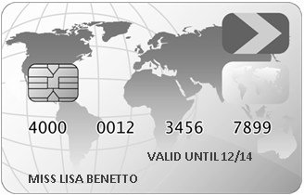

Question 1: NEW DEBIT CARD PF016Q01

The following day, Lisa receives the Personal Identification Number (PIN) for the debit card.

What should Lisa do with the PIN?

A Write the PIN on notepaper and keep this in her wallet.
B Tell the PIN to her friends.
C Write the PIN on the back of the card.
D Memorize the PIN.

SCORING

Question intent: Recognize safe practice of using a card with a PIN

Full Credit

D. Memorize the PIN.

No Credit

Other responses.

shares
This graph shows the price of one Rich Rock share over a 12-month period.
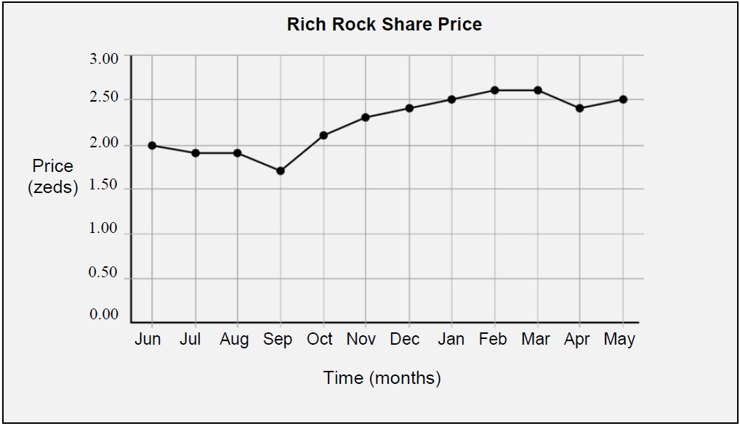

Question 1: shares PF098Q01

Which statements about the graph are true?

Circle “True” or “False” for each statement.

Statement | Is the statement true or false?
The best month to buy the shares was September. | True / False
The share price increased by about 50% over the year. | True / False

SCORING

Question intent: Interpret a line graph showing share prices over one year

Full Credit

Two correct responses: True, False, in that order.

No Credit

Fewer than two correct responses.

motorCYCLE insurance

Last year, Steve’s motorcycle was insured with the PINSURA insurance company.

The insurance policy covered damage to the motorcycle from accidents and theft of the motorcycle.

Question 1: MOTORCYCLE INSURANCE PF002Q01

Steve plans to renew his insurance with PINSURA this year, but a number of factors in Steve’s life have changed since last year.

How is each of the factors in the table likely to affect the cost of Steve’s motorcycle insurance this year?

Circle “Increases cost”, “Reduces cost,” or “Has no effect on cost” for each factor.
Factor | How is the factor likely to affect the cost of Steve’s insurance?
Steve replaced his old motorcycle with a much more powerful motorcycle. | Increases cost / Reduces cost / Has no effect on cost
Steve has painted his motorcycle a different color. | Increases cost / Reduces cost / Has no effect on cost
Steve was responsible for two road accidents last year. | Increases cost / Reduces cost / Has no effect on cost

SCORING

Question intent: Recognize factors affecting motorcycle insurance premiums

Full Credit

Three correct responses: Increases cost, Has no effect on cost, Increases cost, in that order.

No Credit

Fewer than three correct responses.

